ACKNOWLEDGEMENT

TABLE OF CONTENTS

S.NO. CONTENTS

1. INTRODUCTION
1.1 oRGANIZATION pROFILE
1.2 aBSTRACT
2 . SYSTEM ANALYSIS
2.1 Existing System
2.3 Proposed System
2.4 Requirement Analysis
2.5 Requirement Specifications
2.6 Feasibility study
3. SYSTEM DESIGN
3.1 Project Modules
3.2 Data Dictionary
3.3 DATA FLOW DIAGRAMS
  - E-R DIAGRAMS
  - HARDWARE AND SOFTWARE REQUIRMENTS
4. SYSTEM TESTING
5. SOFTWARE TOOLES USED
6. TECHNICLAL NOTES
  - INTRODUCTION TO REAL TIME PROGRAMMING
  - INTRODUCTION TO OOPS AND WINDOWS
  - INTRODUCTION TO JAVA
7. BIBILOGRAPHY

1. INTRODUCTION
1.1 ABSTRACT
The project aims at providing corporate information and hospital statistics can be viewed in a web on the Internet. This Information is to be integrated into the existing web page of the company but the access to it would be restricted to the Chairman and Directors or any body who has been authorized or register users.
According patients needs the hospital management introduce Smart Card Schemes like one year smart card, two year smart card and life long Smart Cards? First Patient chooses the smart card according to the patient requirement, depending on Smart card patient get the discount on medical bill. Every person who is willing to take the smart cards, depending on card value, first they pay Card Value to Organization.
This information is shared to all the branches of the Hospital group so that they can maintain global information of the group.
If the subscriber of the Smart Card is suffering with ill health they will be given initial treatment with out any consultancy charges.

2. SYSTEM ENVIRONMENT
Hardware and Software Specifications
The development of this project deals with the following environment
- Hardware requirements
- Software requirements
2.1 Hardware Requirements:
. The Manufacturing Optimization can be efficiently run on Pentium system with at least 128 MB RAM and Hard disk drive having 20 GB. Floppy disk drive of 1.44 MB and 14 inch Samsung color monitor suits the information system operation.(A Printer is required for hard copy output).
- Pentium processor -------- 233 MHZ or above
- RAM Capacity -------- 128MB
- Hard Disk -------- 20GB
- Floppy disk -------- 1.44 MB
- CD-ROM Drive -------- 32 HZ
- KEYBOARD -------- 108 Standard
2.2 Software Requirements:
One of the most difficult tasks is that, the selection of the software, once system requirement is known is determining whether a particular software package fits the requirements. After initial selection further security is needed to determine the desirability of particular software compared with other candidates. This section first summarizes the application requirement question and then suggests more detailed comparisons.
- Operating System -------- Windows 95/98/NT/2000
- Browser -------- IE
- Web/Application Server -------- Java Web Server2.0, Tomcat5.0
- Database Server -------- Oracle
- Database Connectivity -------- JDBC
- Other Tools & Technologies -------- Java (JDK), Servlets (JSDK), HTML.
3.PROJECTDESCRIPTION

According to Customer Requirements the customer choose card.
During the card validity period , if the customer joined the hospital, the customer get the discount of the total Hospital bill, depending on the card discount. The hospital must be tie up with the Hospital Group.
If the Hospital not tie up with the Hospital Group, the patient do not get the any Discount. Customer get the discount If the card is valid.

MODULES
- Chairman
- Branch Manager

MODULE DESCRIPTION

Chairman Module:

In this System Chairman is the super User. The activity of the chairman is to create a New Branch in different locations depending on requirement. And also assign a New Branch Manager to New Branch.

According to Requirements Chairman generate a New Health Card and also define Card Specifications i.e. card number, card name, Group capacity, validity, Discount, amount.

Chairman has a capacity to remove a Branch Manager and also modify the card specifications .

Chairman to see the reports based on the branch, state, card, and district wise. These reports helpful to improve his business.

The Main Roles of the Chairman are:-

- Create a New Branch Assign a Branch Manager
- Generate a new Type of Health Card
- Assigning of Health Card Specifications

Sub Modules:

Branch:

According requirement the Hospital Group launch a Branches in different Places i.e. (inside Andhra Pradesh and also a outside Andhra Pradesh).

And also assign a Branch Manager to New Branch. Chairman enters the all the details of Branch Manager in database through project. Mainly Manager name, Father’s name, Permanent Address, Telephone number, email address. These types of information enter into Data Base by the Chairman. After that, the Chairman gives to Manager his username and password. Managers login to system with their username and password. This type of Authentication Information will be give to Managers by Chairman.

The chairman has a full privileges on Managers, i.e. transfers to managers to another places, remove the Managers, If a Manager changed his phone number, then chairman has a privilege to update his details.

Card:

The Chairman defined the card specifications, i.e. Card Name, Card Number, Group Limit, Time duration, Discount, Amount. These types of speciation only defined by Chairman Card number is generated dynamically. Here Group limit specification means that maximum number of registrations per Card depending on the type of the card.

Any modifications regarding to card specifications, the chairman only the person modified the card specifications. According to the requirement, the chairman generates the new cards and also defines the specifications.

The chairman has a authority to delete the card or modifications of card specifications depending on requirement.

The smart card value defined by the Chairman. The customer must have to pay full card amount. In future, the customer will suffer any disease, then the customer will join any Hospital belongs to Hospitals Group, the customer will get discount on total Hospital Bill.

These types of smart cards are very helpful to customers. Once Customer get a smart card, then the customer get discount of any Hospital, that hospital belongs to Hospital Group.

The customer registers any one of Branch, then customer will get discount any Hospital. Here the all branches will share database.

Once customers register their registration, there is no way no cancellation of their registration any circumstances.

2. Branch Manager: -

Branch Manager is the head of the Branch, assigned by the Chairman. Branch Manager taking the details from the Customers, who is willing to take the card.

The main activity of the manager is to register the customer details, i.e. card name, cardholder name, age, sex, registration number, phone number, and also relation details depending cardholder.

Branch Manager generates reports according branch wise, district wise, state wise and also card wise. These reports are helpful to improve the branch.

The Main Roles of the Branch Manager are:

- Taking the Enquiry details from Customers.
- Register the New Customers
- And also Register the customer Relation details
- Modify the Customer Details (If required)

Sub Modules:

Enquiry:-
In this Module, Branch Manager first enters the customer details, for future correspondence and also estimates the static’s of business.

Registration:-
Every Branch has a one Branch Manager. Branch Manager has a Superior of the Branch. Branch manager register the customer details.

4. SOFTWARESPECIFICATION
4.1 FRONTEND

OVERVIEW OF JAVA TECHNOLOGY
HISTORY OF JAVA
Java language was developed by James Gosling and his team at sun micro systems and released formally in 1995. Its former name is oak. Java Development Kit 1.0 was released in 1996. to popularize java and is freely available on Internet.
Overview of Java
Java is loosely based on C++ syntax, and is menat to be Object-Oriented Structure of java is midway between an interpreted and a compiled language . java programs are compiled by the java compiler into Byte Codes which are secure and portable across different platforms . these byte codes are essentially instructions encapsulated in single type, to what is known as ajava virtual machine (JVM) which resides instandard browser.
Jvm verifies these byte codes when downloaded by the browser for integrity. Jvms available for almost all OS. JVM converts these byte codes into machine specific instructions at runtime.
FEATURES OF JAVA
- java is object-oriented language and supports encapsulation, inheritance , polymorphism and dynamic binding , but does not support multiple inheritance.every thing in java is an object except some primitive datatypes .
- java is portable architecture neutral that is java programs once compiled can be executed on any machine that is enabled.
- JAVA is distributed in its approach and used for internet programming.
- Java is robust, secured, high performing and dynamic in nature.
- Java supports multithreading. There for different parts of the program can be executed at the same time

JAVA AND INTERNET
Java is strongly associated with internet and known as internet programming language. Internet users can use java to create applet programs and run them locally using java enabled browser search as hot java. Applets can be downloaded from remote machine via internet and run it on local machine .

JAVA AND WORLD WIDE WEB
World wide web is an open ended information retrieval system designed to be used in the distributed environment. This system contains web pages that provide both information and controls. We can navigate to a new web page in any direction. This is made possible worth HTML java was meant to be used in distributed environment such as internet. So java could be easily incorporated into the web system and is capable of supporting animation graphics , games and other special effect. The web has become more dynamic and interactive with support of java. We can run a java program on remote machine over internet with the support of web .

JAVA ENVIRONMENT
Java environment includes a large no.of tools which are part of the system known as java development kit (JDK) and hundreds of classes, methods, and interfaces grouped into packages forms part of java standard library(JSL).

JAVA ARCHITECTURE
Java architecture provides a portable , robust , high performing environment for development. Java provides portability by compiling the byte codes for the java virtual machine which are then interpreted on each platform by the runtime environment . java also provides stringent compile and runtime checking and automatic memory management in order to ensure solid code .

JAVA VIRTUAL MACHINE
When we compile the code, java compiler creates machine code (byte code) for a hypothetical machine called java virtual machine (jvm). The jvm will execute the byte code and overcomes the issue of portability . the code is written and compile for one machine and interpreted all other machines . this machine is called java virtual machine .

PARADIGM OF JAVA
- Dynamic down loading applets(small application programs);
- Elimination of flatware phenomenon that is providing those features of a product that user needs at a time. The remaining features of a product can remain in the server.
- Changing economic model of the software
- Up-to-date software availability
- Supports network entire computing
- Supports CORBA & DCOM

ABOUT HTML
HTML (hyper text markup language) is a language used to create hyper text documents that have hyper links embedded in them . it consists of tags embedded in the text of a document with HTML. We can build web pages or web document s. it is basically a formatting language and not a programming language. The browser reading the document interprets mark up tags to help format the document for subsequent display to a reader. HTML is a language for describing structured documents. HTML is a platform independent. WWW(world wide web) pages are written using HTML. HTML tags control in part the representation of the WWW page when view with web browser. The browser interpretes HTML tags in the web document and displays it. Different browsers show data differently. Examples of browsers used to be web pages include:
- Netscape
- Internet Explorer

JAVA SCRIPT
Java script is a general purpose , prototype based , object oriented scripting language developed jointly by sun and netscape and is meant for the WWW . it is designed to be embedded in diverse applications and systems , with out consuming much memory . java script borrows most of its syntax from java but also inherits from awk and perl , with some indirect influence from self in its object prototype system.
Java scripts dynamically typed that is programs donot declare variable types, and the type of variable is unrestricted and can change at runtime . source can be generated at run time and evaluated against an arbitrary scope. Typical implementations compile by translating source into a specified byte code format, to check syntax and source consistency. Note that the availability to generate and interprate programs at runtime implies the presence of a compiler at runtime.
Java script is a high level scripting language that does not depend on or expose particular machine representations or operating system services. It provides automatic storage management, typically using a garbage collector.

FEATURES:
- Java script is embedded into HTML documents and is executed with in them.
- Java script is browser dependent
- Javascript is an interpreted languaged that can be interpreted by the browser at run time .
- Java script is loosely typed language
- Java script is an object based language.
- Java script is an Eent-Driven language and supports event handlers to specify the functionality of a button.

ADVANTAGES
  - java script can be used for client side application
  - java script provides means to contain multiframe windows for presentation of the web.
  - java script provides basic data validation before it is sent to the server. Eg : login and password checking or whether the values entered are correct or whether all fields in a from are filled and reduced network traffic
  - it creates interactive forms and client side lookup tables .

Introduction to Servlets
Servlets provide a Java^{(TM)}-based solution used to address the problems currently associated with doing server-side programming, including inextensible scripting solutions, platform-specific APIs, and incomplete interfaces.
Servlets are objects that conform to a specific interface that can be plugged into a Java-based server. Servlets are to the server-side what applets are to the client-side -- object bytecodes that can be dynamically loaded off the net. They differ from applets in that they are faceless objects (without graphics or a GUI component). They serve as platform-independent, dynamically-loadable, pluggable helper bytecode objects on the server side that can be used to dynamically extend server-side functionality.

What is a Servlet?
Servlets are modules that extend request/response-oriented servers, such as Java-enabled web servers. For example, a servlet might be responsible for taking data in an HTML order-entry form and applying the business logic used to update a company's order database.
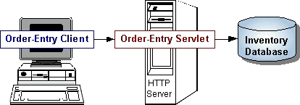
Servlets are to servers what applets are to browsers. Unlike applets, however, servlets have no graphical user interface.
Servlets can be embedded in many different servers because the servlet API, which you use to write servlets, assumes nothing about the server's environment or protocol. Servlets have become most widely used within HTTP servers; many web servers support the Servlet API.

Use Servlets instead of CGI Scripts!
Servlets are an effective replacement for CGI scripts. They provide a way to generate dynamic documents that is both easier to write and faster to run. Servlets also address the problem of doing server-side programming with platform-specific APIs: they are developed with the Java Servlet API, a standard Java extension.
So use servlets to handle HTTP client requests. For example, have servlets process data POSTed over HTTPS using an HTML form, including purchase order or credit card data. A servlet like this could be part of an order-entry and processing system, working with product and inventory databases, and perhaps an on-line payment system.

Other Uses for Servlets
Here are a few more of the many applications for servlets:
- Allowing collaboration between people. A servlet can handle multiple requests concurrently, and can synchronize requests. This allows servlets to support systems such as on-line conferencing.
- Forwarding requests. Servlets can forward requests to other servers and servlets. Thus servlets can be used to balance load among several servers that mirror the same content, and to partition a single logical service over several servers, according to task type or organizational boundaries.
Architecture of the Servlet Package
The javax.servlet package provides interfaces and classes for writing servlets. The architecture of the package is described below.
The Servlet Interface
The central abstraction in the Servlet API is the Servlet interface. All servlets implement this interface, either directly or, more commonly, by extending a class that implements it such as HttpServlet.
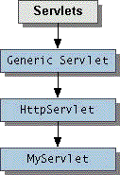
The Servlet interface declares, but does not implement, methods that manage the servlet and its communications with clients. Servlet writers provide some or all of these methods when developing a servlet.

Client Interaction
When a servlet accepts a call from a client, it receives two objects:
- A ServletRequest, which encapsulates the communication from the client to the server.
- A ServletResponse, which encapsulates the communication from the servlet back to the client.
ServletRequest and ServletResponse are interfaces defined by the javax.servlet package.

The ServletRequest Interface
The ServletRequest interface allows the servlet access to:
- Information such as the names of the parameters passed in by the client, the protocol (scheme) being used by the client, and the names of the remote host that made the request and the server that received it.
- The input stream, ServletInputStream. Servlets use the input stream to get data from clients that use application protocols such as the HTTP POST and PUT methods.
Interfaces that extend ServletRequest interface allow the servlet to retrieve more protocol-specific data. For example, the HttpServletRequest interface contains methods for accessing HTTP-specific header information.
The ServletResponse Interface
The ServletResponse interface gives the servlet methods for replying to the client. It:
Allows the servlet to set the content length and MIME type of the reply.
- Provides an output stream, ServletOutputStream, and a Writer through which the servlet can send the reply data.
Interfaces that extend the ServletResponse interface give the servlet more protocol-specific capabilities. For example, the HttpServletResponse interface contains methods that allow the servlet to manipulate HTTP-specific header information.

Additional Capabilities of HTTP Servlets
The classes and interfaces described above make up a basic Servlet. HTTP servlets have some additional objects that provide session-tracking capabilities. The servlet writer can use these APIs to maintain state between the servlet and the client that persists across multiple connections during some time period. HTTP servlets also have objects that provide cookies. The servlet writer uses the cookie API to save data with the client and to retrieve this data.
The classes mentioned in the Architecture of the Servlet Package section are shown in the example in bold:
- SimpleServlet extends the HttpServlet class, which implements the Servlet interface.
- SimpleServlet overrides the doGet method in the HttpServlet class. The doGet method is called when a client makes a GET request (the default HTTP request method), and results in the simple HTML page being returned to the client.
- Within the doGet method,
  - The user's request is represented by an HttpServletRequest object.
  - The response to the user is represented by an HttpServletResponse object.
  - Because text data is returned to the client, the reply is sent using the Writer object obtained from the HttpServletResponse object.

Servlet Lifecycle
Each servlet has the same life cycle:
- A server loads and initializes the servlet
- The servlet handles zero or more client requests
- The server removes the servlet

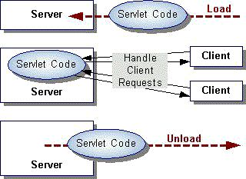

Initializing a Servlet
When a server loads a servlet, the server runs the servlet's init method. Initialization completes before client requests are handled and before the servlet is destroyed.
Even though most servlets are run in multi-threaded servers, servlets have no concurrency issues during servlet initialization. The server calls the init method once, when the server loads the servlet, and will not call the init method again unless the server is reloading the servlet. The server can not reload a servlet until after the server has destroyed the servlet by calling the destroy method.
The init Method
The init method provided by the HttpServlet class initializes the servlet and logs the initialization. To do initialization specific to your servlet, override the init() method following these rules:
- If an initialization error occurs that renders the servlet incapable of handling client requests, throw an UnavailableException.
An example of this type of error is the inability to establish a required network connection.
Do not call the System.exit method

Initialization Parameters
The second version of the init method calls the getInitParameter method. This method takes the parameter name as an argument and returns a String representation of the parameter's value.
The specification of initialization parameters is server-specific. In the Java Web Server, the parameters are specified with a servlet is added then configured in the Administration Tool. For an explanation of the Administration screen where this setup is performed, see the Administration Tool: Adding Servlets online help document.
If, for some reason, you need to get the parameter names, use the getParameterNames method.

Destroying a Servlet
Servlets run until the server are destroys them, for example at the request of a system administrator. When a server destroys a servlet, the server runs the servlet's destroy method. The method is run once; the server will not run that servlet again until after the server reloads and reinitializes the servlet.
When the destroy method runs, another thread might be running a service request. The Handling Service Threads at Servlet Termination section shows you how to provide a clean shutdown when there could be long-running threads still running service requests.

Using the Destroy Method
The destroy method provided by the HttpServlet class destroys the servlet and logs the destruction. To destroy any resources specific to your servlet, override the destroy method. The destroy method should undo any initialization work and synchronize persistent state with the current in-memory state.
The following example shows the destroy method that accompanies the init method shown previously:
public class BookDBServlet extends GenericServlet {
private BookstoreDB books;
... // the init method
public void destroy() {
// Allow the database to be garbage collected
books = null;
}
}

A server calls the destroy method after all service calls have been completed, or a server-specific number of seconds have passed, whichever comes first. If your servlet handles any long-running operations, service methods might still be running when the server calls the destroy method. You are responsible for making sure those threads complete. The next section shows you how.
The destroy method shown above expects all client interactions to be completed when the destroy method is called, because the servlet has no long-running operations.

Handling Service Threads at Servlet Termination
All of a servlet's service methods should be complete when a servlet is removed. The server tries to ensure this by calling the destroy method only after all service requests have returned, or after a server-specific grace period, whichever comes first. If your servlet has operations that take a long time to run (that is, operations that may run longer than the server's grace period), the operations could still be running when destroy is called. You must make sure that any threads still handling client requests complete; the remainder of this section describes a technique for doing this.
If your servlet has potentially long-running service requests, use the following techniques to:
- Keep track of how many threads are currently running the service method.
- Provide a clean shutdown by having the destroy method notify long-running threads of the shutdown and wait for them to complete
- Have the long-running methods poll periodically to check for shutdown and, if necessary, stop working, clean up and return.

Tracking Service Requests
To track service requests, include a field in your servlet class that counts the number of service methods that are running. The field should have access methods to increment, decrement, and return its value.
The service method should increment the service counter each time the method is entered and decrement the counter each time the method returns. This is one of the few times that your HttpServlet subclass should override the service method. The new method should call super.service to preserve all the original HttpServlet.service method's functionality.

Providing a Clean Shutdown
To provide a clean shutdown, your destroy method should not destroy any shared resources until all the service requests have completed. One part of doing this is to check the service counter. Another part is to notify the long-running methods that it is time to shut down. For this, another field is required along with the usual access methods.

Creating Polite Long-running Methods

The final step in providing a clean shutdown is to make any long-running methods behave politely. Methods that might run for a long time should check the value of the field that notifies them of shut downs, and interrupt their work if neceesary.

Servlet-client Interaction

Handling HTTP Clients
An HTTP Servlet handles client requests through its service method. The service method supports standard HTTP client requests by dispatching each request to a method designed to handle that request. For example, the service method calls the doGet method shown earlier in the simple example servlet.

Requests and Responses
Methods in the HttpServlet class that handle client requests take two arguments:
- An HttpServletRequest object, which encapsulates the data from the client
- An HttpServletResponse object, which encapsulates the response to the client

HttpServletRequest Objects
An HttpServletRequest object provides access to HTTP header data, such as any cookies found in the request and the HTTP method with which the request was made. The HttpServletRequest object also allows you to obtain the arguments that the client sent as part of the request.
To access client data:
- The getParameter method returns the value of a named parameter. If your parameter could have more than one value, use getParameterValues instead. The getParameterValues method returns an array of values for the named parameter. (The method getParameterNames provides the names of the parameters.)
- For HTTP GET requests, the getQueryString method returns a String of raw data from the client. You must parse this data yourself to obtain the parameters and values.
- For HTTP POST, PUT, and DELETE requests,
  - If you expect text data, the getReader method returns a BufferedReader for you to use to read the raw data.
  - If you expect binary data, the getInputStream method returns a ServletInputStream for you to use to read the raw data

Note: Use either a getParameter[Values] method or one of the methods that allow you to parse the data yourself. They can not be used together in a single request.

HttpServletResponse Objects
An HttpServletResponse object provides two ways of returning data to the user:
- The getWriter method returns a Writer
- The getOutputStream method returns a ServletOutputStream
Use the getWriter method to return text data to the user, and the getOutputStream method for binary data.
Closing the Writer or ServletOutputStream after you send the response allows the server to know when the response is complete.

HTTP Header Data
You must set HTTP header data before you access the Writer or OutputStream. The HttpServletResponse class provides methods to access the header data. For example, the setContentType method sets the content type. (This header is often the only one manually set.)
Handling GET and POST Requests
The methods to which the service method delegates HTTP requests include,
- doGet, for handling GET, conditional GET, and HEAD requests
- doPost, for handling POST requests
- doPut, for handling PUT requests
- doDelete, for handling DELETE requests
By default, these methods return a BAD_REQUEST (400) error. Your servlet should override the method or methods designed to handle the HTTP interactions that it supports. This section shows you how to implement methods that handle the most common HTTP requests: GET and POST.
The HttpServlet's service method also calls the doOptions method when the servlet receives an OPTIONS request, and doTrace when the servlet receives a TRACE request. The default implementation of doOptions automatically determines what HTTP options are supported and returns that information. The default implementation of doTrace causes a response with a message containing all of the headers sent in the trace request. These methods are not typically overridden.
Servlet Descriptions
In addition to handling HTTP client requests, some applications, such as the Java Web Server's Administration Tool, get descriptive information from the servlet and display it. The servlet description is a string that can describe the purpose of the servlet, its author, its version number, or whatever the servlet author deems important.
The method that returns this information is getServletInfo, which returns null by default. You are not required to override this method, but applications are unable to supply a description of your servlet unless you do.

Writing Your First Servlet
Servlets are also easy to develop. This document discusses the following minimum steps needed to create any servlet:
- Write the servlet
  - Import the necessary Java packages
  - Inherit from GenericServlet or the HTTP convenience class HttpServlet
  - Override the service method (this is where the actual work is done by the servlet)
  - Save the file with a .java filename extension
- Compile the servlet
  - Make sure jws.jar is included in your classpath
  - Invoke javac
- Install the servlet
  - Use the Java Web Server's Administration Tool to install it, and optionally configure it.
- Test the servlet
  - Invoke the servlet from a JDK1.1-compatible browser.

About Session Tracking
Session T tracking is a flexible, lightweight mechanism that enables stateful programming on the web. Its general implementation serves as a basis for more sophisticated state models, such as persistent user profiles or multi-user sessions.
A session is a series of requests from the same user that occur during a time period. This transaction model for sessions has many benefits over the single-hit model. It can maintain state and user identity across multiple page requests. It can also construct a complex overview of user behavior that goes beyond reporting of user hits.

Server-Side Session Objects and Users
Session tracking gives servlets and other server-side applications the ability to keep state information about a user as the user moves through the site. Server-side applications can use this facility to create more stateful user experiences and to track who's doing what on the site.
Java Web Server maintains user state by creating a Session object for each user on the site. These Session objects are stored and maintained on the server. When a user first makes a request to a site, the user is assigned a new Session object and a unique session ID. The session ID matches the user with the Session object in subsequent requests. The Session object is then passed as part of the request to the servlets that handle the request. Servlets can add information to Session objects or read information from them.

Session Endurance
After the user has been idle for more than a certain period of time (30 minutes by default), the user's session becomes invalid, and the corresponding Session object is destroyed.

A session is a set of requests originating from the same browser, going to the same server, bounded by a period of time. Loosely speaking, a session corresponds to a single sitting of a single anonymous user (anonymous because no explicit login or authentication is required to participate in session tracking).
The first part of the doGet method associates the Session object with the user making the request. The second part of the method gets an integer data value from the Session object and increments it. The third part outputs the page, including the current value of the counter.
When run, this servlet should output the value of the counter that increments every time you reload the page. You must obtain the Session object before you actually write any data to the servlet's output stream. This guarantees that the session tracking headers are sent with the response.
The Session object has methods similar to java.util.Dictionary for adding, retrieving, and removing arbitrary Java objects. In this example, an Integer object is read from the Session object, incremented, then written back to the Session object.
Any name, such as sessiontest.counter, may be used to identify values in the Session object. When choosing names, remember that the Session object is shared among any servlets that the user might access. Servlets may access or overwrite each other's values from the Session. Thus, it is good practice to adopt a convention for organizing the namespace to avoid collisions between servlets, such as:
servletname.name

Session Invalidation
Sessions can be invalidated automatically or manually. Session objects that have no page requests for a period of time (30 minutes by default) are automatically invalidated by the Session Tracker sessionInvalidationTime parameter. When a session is invalidated, the Session object and its contained data values are removed from the system.
After invalidation, if the user attempts another request, the Session Tracker detects that the user's session was invalidated and creates a new Session object. However, data from the user's previous session will be lost.
Session objects can be invalidated manually by calling Session.invalidate(). This will cause the scession to be invalidated immediately, removing it and its data values from the system.

Handling Non-Cookie Browsers (URL Rewriting)
s The Session Tracker uses a session ID to match users with Session objects on the server side. The session ID is a string that is sent as a cookie to the browser when the user first accesses the server. On subsequent requests, the browser sends the session ID back as a cookie, and the server uses this cookie to find the session associated with that request.
There are situations, however, where cookies will not work. Some browsers, for example, do not support cookies. Other browsers allow the user to disable cookie support. In such cases, the Session Tracker must resort to a second method, URL rewriting, to track the user's session.
URL rewriting involves finding all links that will be written back to the browser, and rewriting them to include the session ID. For example, a link that looks like this:
<a href="/store/catalog">
might be rewritten to look like this:
<a href="/store/catalog;$sessionid$DA32242SSGE2">
If the user clicks on the link, the rewritten form of the URL will be sent to the server. The server's Session Tracker will be able to recognize the ;$sessionid$DA32242SSGE2 and extract it as the session ID. This is then used to obtain the proper Session object.
Implementing this requires some reworking by the servlet developer. Instead of writing URLs straight to the output stream, the servlet should run the URLs through a special method before sending them to the output stream.
The encodeUrl method performs two functions:
- Determine URL Rewriting: The encodeUrl method determines if the URL needs to be rewritten. Rules for URL rewriting are somewhat complex, but in general if the server detects that the browser supports cookies, then the URL is not rewritten. The server tracks information indicating whether a particular user's browser supports cookies.
- Return URL (modified or the same): If the encodeUrl method determined that the URL needs to be rewritten, then the session ID is inserted into the URL and returned. Otherwise, the URL is returned unmodified.
In addition to URLs sent to the browser, the servlet must also encode URLs that would be used in sendRedirect() calls. For example, a servlet that used to do this:
response.sendRedirect ("http://myhost/store/catalog");
should now do this:
response.sendRedirect
(response.encodeRedirectUrl ("http://myhost/store/catalog"));
The methods encodeUrl and encodeRedirectUrl are distinct because they follow different rules for determining if a URL should be rewritten.
Multiple Servlets
URL conversions are required only if the servlet supports session tracking for browsers that do not support cookies or browsers that reject cookies. The consequences of not doing these conversions is that the user's session will be lost if the user's browser does not support cookies and the user clicks on an un-rewritten URL. Note that this can have consequences for other servlets. If one servlet does not follow these conventions, then a user's session could potentially be lost for all servlets.

Using Session Tracking with the Page Compiler
Page compilation is a feature of the Java Web Server that allows HTML pages containing Java code to be compiled and run as servlets. Page compilation also simplifies the task of supporting session tracking. To that end, if URL rewriting is enabled, page compilation automatically adds the encodeUrl call to links in the HTML page.

Additional APIs
In addition to the Session object, there are a few more classes that may interest the servlet developer.
Description | Class
HttpSessionContext | The HttpSessionContext is the object that contains all existing and valid sessions. The HttpSessionContext can be obtained by calling getSessionContext() on the Session object. The HttpSessionContext lets you find other Session objects by their IDs and list the IDs of all valid sessions.
HttpSessionBindingListener | HttpSessionBindingListener is an interface that can be implemented by objects placed into a Session. When the Session object is invalidated, its contained values are also removed from the system. Some of these values may be active objects that require cleanup operations when their session is invalidated. If a value in a Session object implements HttpSessionBindingListener, then the value is notified when the Session is invalidated, thereby giving the object a chance to perform any necessary cleanup operations.

Session Swapping and Persistence
An Internet site must be prepared to support many valid sessions. A large site, for example, might have hundreds, or even thousands, of simultaneously valid sessions. Because each session can contain arbitrary data objects placed there by the application servlets, the memory requirements for the entire system can
grow prohibitively large.
To alleviate some of these problems, the session tracking system places a limit on the number of Session objects that can exist in memory. This limit is set in the session.maxresidents property. When the number of simultaneous sessions exceeds this number, the Session Tracker swaps the least recently-used sessions out to files on disk. Those sessions are not lost: they will be reloaded into memory if further requests come in for those sessions. This system allows for more sessions to remain valid than could exist in memory.
Session invalidation is not affected by session swapping. If a session goes unused for longer than the normal invalidation time, the session is invalidated, whether it is in memory or on disk. Session invalidation is set in the session.invalidationinterval property.
Sessions are written to and read from disk using Java serialization. For this reason, only serializable objects put into the Session object will be written to disk. Any objects put into the Session object that are not serializable will remain in memory, even if the rest of the Session object has been written to disk. This does not affect session tracking, but does reduce the memory savings that the Session Tracker gets from swapping a session to disk. For this reason, the servlet developer should try to put only serializable objects into the Session object. Serializable objects are those that implement either java.io.Serializable or java.io.Externalizable.
The session-swapping mechanism is also used to implement session persistence, if the session persistence feature is enabled. When the server is shut down, sessions still in memory are written to the disk as specified in the session.swapdirectory property. When the server starts again, sessions that were written to disk will once again become valid. This allows the server to be restarted without losing existing sessions. Only serializable data elements in the session will survive this shutdown/restart operation.
Note: Session persistence is intended for preserving sessions across server restarts. It is not meant to be used as a general long-term session persistence mechanism.

Customizing Session Tracking
Session-tracking interfaces are in the javax.servlet.http package.

Properties
You can customize properties in the Session Tracker. The properties are kept in the server.properties files at:
<server_root>/properties/server/javawebserver/server.properties
where <server_root> is the directory into which you installed the Java Web Server product.
Note: These property settings are applied to all sessions, and cannot be tuned for individual sessions.
Parameter | Description | Default
session.invalidationinterval | Time interval when Java Web Server checks for sessions that have gone unused long enough to be invalidated. Value is an integer, specifying the interval in milliseconds. | 10000  (10 seconds)
session.swapinterval | Time interval when Java Web Server checks if too many sessions are in memory, causing the overflow of sessions to be swapped to disk. Value is an integer, specifying the interval in milliseconds. | 10000  (10 seconds)
session.persistence | Boolean value specifying if Java Web Server keeps session data persistent. If true, sessions are swapped to disk when Java Web Server shuts down and are revalidated from disk when it restarts. If false, Java Web Server removes session swap files every time it starts. | true
session.swapdirectory | Name of directory that the Java Web Server uses to swap out session data. No other data should be kept in this directory. | sessionSwap
session.maxresidents | Number of sessions allowed to remain in memory at once. If the number of sessions exceeds this number, sessions will be swapped out to disk on a least recently used basis to reduce the number of resident sessions. | 1024
session.invalidationtime | Amount of time a session is allowed to go unused before it is invalidated. Value is specified in milliseconds. | 1800000  (30 minutes)
enable.sessions | Boolean value specifying whether Session Tracking is active. If false, then the Java Web Server performs no function for extracting or inserting session IDs into requests. | true
enable.cookies | Boolean value indicating whether Java Web Server uses cookies as a vehicle for carrying session ID. If true, session IDs arriving as cookies are recognized and the Java Web Server tries to use cookies as a means for sending the session ID. | true
enable.urlrewriting | Boolean value indicating whether Java Web Server uses rewritten URLs as a vehicle to carry the session ID. If true, then session IDs arriving in the URL are recognized, and the Java Web Server rewrites URLs if necessary to send the session ID. | false
enable.protocolswitchrewriting | Boolean value indicating whether the session ID is added to URLs when the URL dictates a switch from "http" to "https" or vice-versa. | false
session.cookie.name | Name of the cookie used to carry the session ID, if cookies are in use. | jwssessionid
session.cookie.comment | Comment of the cookie used to carry the session ID, if cookies are in use. | Java Web Server Session Tracking Cookie
session.cookie.domain | If present, this defines the value of the domain field that is sent for session cookies. | null
session.cookie.maxage | If present, this defines the value of the maximum age of the cookie. | -1
session.cookie.path | If present, this defines the value of the path field that will be sent for session cookies. | "/"
session.cookie.secure | If true, then session cookies will include the secure field. | false

4.2 BACKEND
ORACLE
INTRODUCTION:
Oracle is a relational database management system, which organizes data in the form of tables. Oracle is one of many database servers based on RDBMS model, which manages a seer of data that attends three specific things-data structures, data integrity and data manipulation. With oracle cooperative server technology we can realize the benefits of open, relational systems for all the applications. Oracle makes efficient use of all systems resources, on all hardware architecture; to deliver unmatched performance, price performance and scalability. Any DBMS to be called as RDBMS has to satisfy Dr.E.F.Codd’s rules.

DISTINCT FEATURES OF ORACLE:

- ORACLE IS PORTABLE:

The Oracle RDBMS is available on wide range of platforms ranging from PCs to super computers and as a multi user loadable module for Novel NetWare, if you develop application on system you can run the same application on other systems without any modifications.

- ORACLE IS COMPATIBLE:

Oracle commands can be used for communicating with IBM DB2 mainframe RDBMS that is different from Oracle, that is Oracle compatible with DB2. Oracle RDBMS is a high performance fault tolerant DBMS, which is specially designed for online transaction processing and for handling large database applications.

SYSTEM ANALYSIS

2.SYSTME ANALYSIS

system analysis first stage according to System Development Life Cycle model. This System Analysis is a process that starts with the analyst.

Analysis is a detailed study of the various operations performed by a system and their relationships within and outside the system. One aspect of analysis is defining the boundaries of the system and determining whether or not a candidate should consider other related systems. During analysis, data is collected from the available files, decision points, and transactions handled by the present system.

Logical system models and tools are used in analysis. Training, experience, and common sense are required for collection of the information needed to do the analysis.

EXISTING SYSTEM:
In the existing system the patient or the user has to go the hospital with his total prescriptions and everything. It is also very economic if you went to multispecialty hospitals and also when you transfer or migrate from one location to another location.
PROPOSED SYSTEM:
In the proposed system no need to take all the prescription with us because it stored in the database and it is also economically good because they will provide the concisions for the patients who are registered with that organization.

REQURIEMENTS ANALYSIS

The requirement phase basically consists of three activities:
- Requirement Analysis
- Requirement Specification
- Requirement Validation

Requirement Analysis:
Requirement Analysis is a software engineering task that bridges the gap between system level software allocation and software design. It provides the system engineer to specify software function and performance, indicate software’s interface with the other system elements and establish constraints that software must meet.
The basic aim of this stage is to obtain a clear picture of the needs and requirements of the end-user and also the organization. Analysis involves

interaction between the clients and the analysis. Usually analysts research a problem from any questions asked and reading existing documents. The analysts have to uncover the real needs of the user even if they don’t know them clearly. During analysis it is essential that a complete and consistent set of specifications emerge for the system. Here it is essential to resolve the contradictions that could emerge from information got from various parties.
This is essential to ensure that the final specifications are consistent.
It may be divided into 5 areas of effort.
- Problem recognition
- Evaluation and synthesis
- Modeling
- Specification
- Review

Each Requirement analysis method has a unique point of view. However all analysis methods are related by a set of operational principles. They are
- The information domain of the problem must be represented and understood.

- The functions that the software is to perform must be defined.

- The behavior of the software as a consequence of external events must be defined.

- The models that depict information, function and behavior must be partitioned in a hierarchical or layered fashion.

- The analysis process must move from essential information to implementation detail.

REQUIREMENTS SPECIFICATION

Specification Principles:

Software Requirements Specification plays an important role in creating quality software solutions. Specification is basically a representation process. Requirements are represented in a manner that ultimately leads to successful software implementation.
Requirements may be specified in a variety of ways. However there are some guidelines worth following: -
- Representation format and content should be relevant to the problem
- Information contained within the specification should be nested
- Diagrams and other notational forms should be restricted in number and consistent in use.
- Representations should be revisable.

Software Requirements Specifications:
The software requirements specification is produced at the culmination of the analysis task. The function and performance allocated to the software as a part of system engineering are refined by establishing a complete information description, a detailed functional and behavioral description, and indication of performance requirements and design constraints, appropriate validation criteria and other data pertinent to requirements.

An outline of the Software Requirements Specification:
A simplified outline can be given for the framework of the specifications. This is according to the IEEE Standards.

FEASIBILITY STUDY

All projects are feasible, given unlimited resources and infinite time. But the development of software is plagued by the scarcity of resources and difficult delivery rates. It is both necessary and prudent to evaluate the feasibility of a project at the earliest possible time.
Three key considerations are involved in the feasibility analysis.

Economic Feasibility:

This procedure is to determine the benefits and savings that are expected from a candidate system and compare them with costs. If benefits outweigh costs, then the decision is made to design and implement the system. Otherwise, further justification or alterations in proposed system will have to be made if it is to have a chance of being approved. This is an ongoing effort that improves in accuracy at each phase of the system life cycle.

Technical Feasibility:

Technical feasibility centers on the existing computer system (hardware, software, etc.,) and to what extent it can support the proposed addition. If the budget is a serious constraint, then the project is judged not feasible.

Operational Feasibility:

People are inherently resistant to change, and computers have been known to facilitate change. It is understandable that the introduction of a candidate system requires special effort to educate, sell, and train the staff on new ways of conducting business.

SYSTEM DESIGN

The most creative and challenging phase of the life cycle is system design. The term design describes a final system and the process by which it is developed. It refers to the technical specifications that will be applied in implementations of the candidate system. The design may be defined as “the process of applying various techniques and principles for the purpose of defining a device, a process or a system with sufficient details to permit its physical realization”.
The designer’s goal is how the output is to be produced and in what format. Samples of the output and input are also presented. Second input data and database files have to be designed to meet the requirements of the proposed output. The processing phases are handled through the program Construction and Testing. Finally, details related to justification of the system and an estimate of the impact of the candidate system on the user and the organization are documented and evaluated by management as a step toward implementation.
The importance of software design can be stated in a single word “Quality”. Design provides us with representations of software that can be assessed for quality. Design is the only way where we can accurately translate a customer’s requirements into a complete software product or system. Without design we risk building an unstable system, that might fail if small changes are made. It may as well be difficult to test, or could be one who’s

quality can’t be tested. So it is an essential phase in the development of a software product.

DATA FLOW DIAGRAMS

Data flow diagram is a structure analysis tool that is used for graphical representation of Data processes through any organization . the data flow approach emphasis on the logic underlying the system, by using combination of only 4 symbols. It follows a top down approach. A full description of a system actually consists of set of DFD s , which comprises of various levels. And initial over view model is exploded lower level diagrams that show additional feature of the system. Further each process can be broken down into a more detailed DFD. This occurs repeatedly until sufficient details is described.

DFD symbols
square

it defines a source (originator ) or destination of system data.

Arrow

It indicates data flow-data in motion. It is a pipeline through which information flows.

Circle or Bubble

It represents a process that transforms incoming data flow(s) into outgoing data flow(s).

Open Rectangle

it is a data store-data at rest, or a temporary repository of data. Here I am giving only the Data Flow Diagram.

They are explained by
- GANE and SARON method
- DEMACRO YORDAN method

GANE AND SARSON NOTATION

DATA FLOW

DATA STRUCTURE

EXTERNAL ENTITY
OR DATA LINK

PROCESS

DATA BASE

DEMACRO YORDAN NOTATION

DATA FLOW

DATA STRUCTURE

EXTERNAL ENTITY
OR DATA LINK

PROCESS

Er-Diagrams

ER diagram

Pin
Bno
Branch
CNO
CNAME
CAPACITY
VALIDITY
AMOUNT
DISCOUNT
REGNO
HNAME
DESIGNATION
SEX
QUALIFICATION
PIN
STATE
NAME
PHONE
USER
NAME
PASS
WORD
EMAIL
MOBILE
JDATE
ADDRESS
BRANCH
City
State

Reg
Branch Head
BRANCH
PHONE
ADDRESS
JDATE
CNO
BRANCH
PHONE
CNAME
CAPACITY
VALIDITY
DISCOUNT
REGNO
HNAME
DESIGNATION
SEX
ADDRESS
PIN
STATE
JDATE
Cno
Cno
Cname
Capacity
Validity
Discount
Amount

Reg

Card
NAME
PHONE
USER
NAME
PASS
WORD
EMAIL
MOBILE
JDATE
ADDRESS
BRANCH
City
Pin
State
Bno
Branch

QUALIFICATION
State
Phone
Nsize
Branch
Bdate
Age
District
Sex
DESIGNATION
Name
Address
Branch Head
Enquiry
CNO
BRANCH
PHONE
CNAME
CAPACITY
VALIDITY
DISCOUNT
REGNO
HNAME
DESIGNATION
SEX
QUALIFICATION
ADDRESS
PIN
STATE
JDATE
RegNo
REGNO
NAME1
SEX1
AGE1
RELATION

Reg
Regdesc

I-DFD for Chairman

Smartcard Health Security
system
Add New Branch

Chairman
Assign a Branch Manager

Add New Health Card

Generate Reports

I-DFD for Branch Manager

Smartcard Health Security
system
Branch Manager
Enquiry
Registration

Register Relations

Generate Reports

II-level DFD for Chairman

Branch
Smart Card Health Security System
Assign a Branch Manager
Add New Health Card
Generate Reports
Chairman

Card

Data
Base

II-level DFD for Branch Manager

Smart Card Health Security System
Branch Manager
Registration
Relations
Enquiry
Enquiry

Reg

Red Desc

Generate Reports
Data Base

UML’S

Use Case Diagram of Chairman:

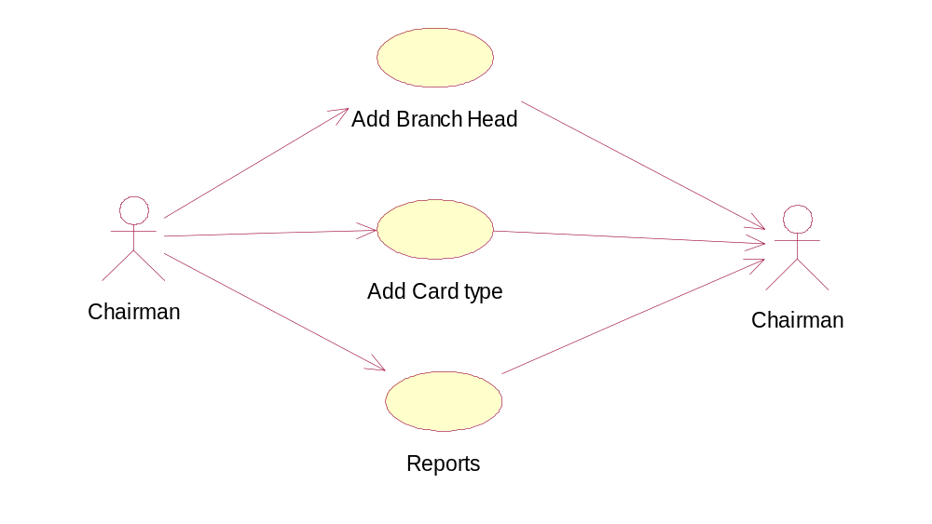

Use case Diagram of BranchHead:

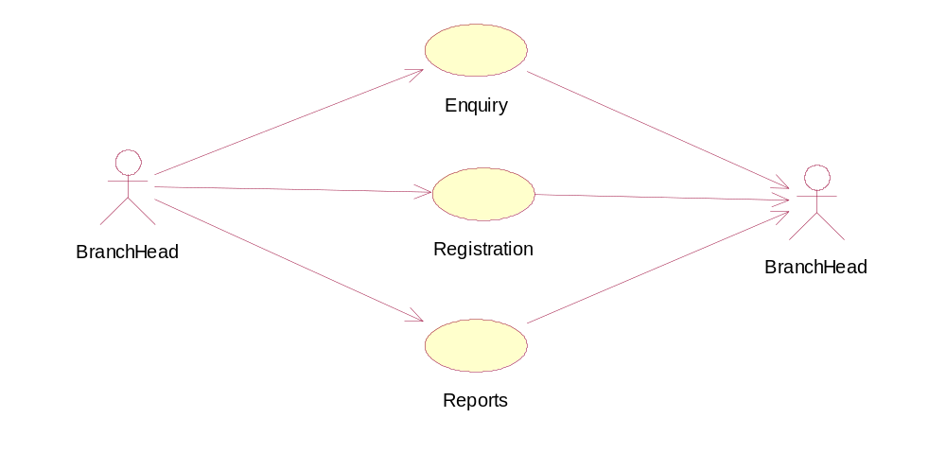

Sequence Diagram of Chairman:

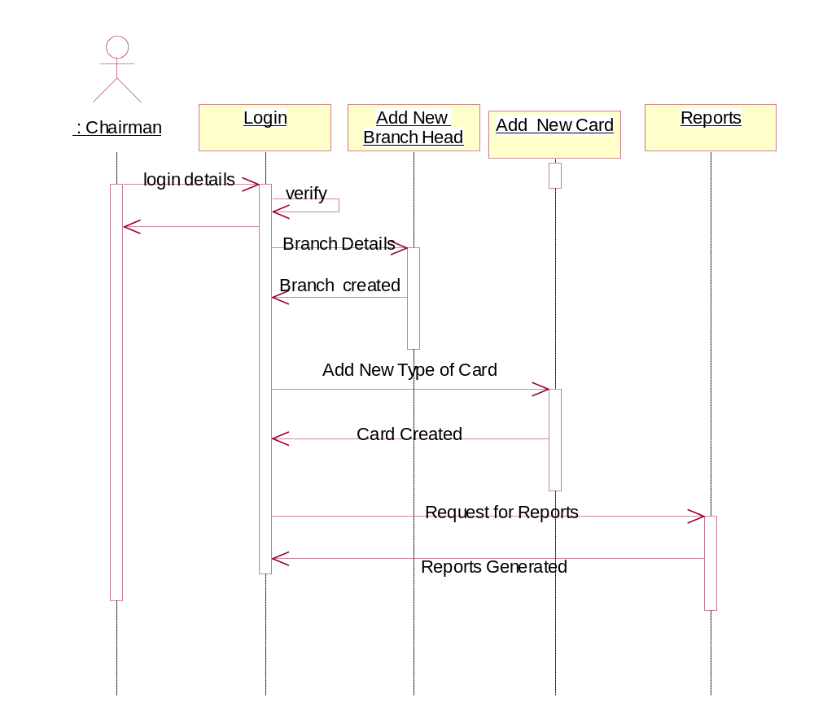

Collaboration Diagram of Chairman :

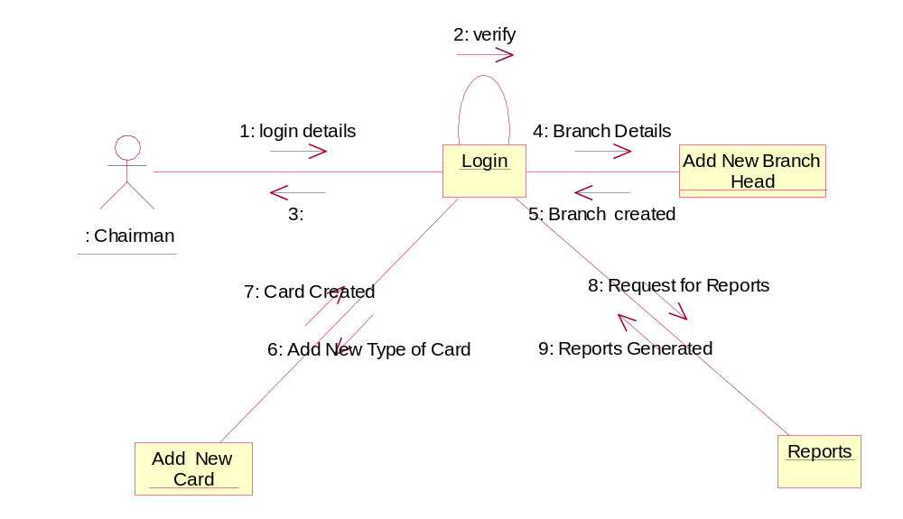

Sequence Diagram of BranchHead:

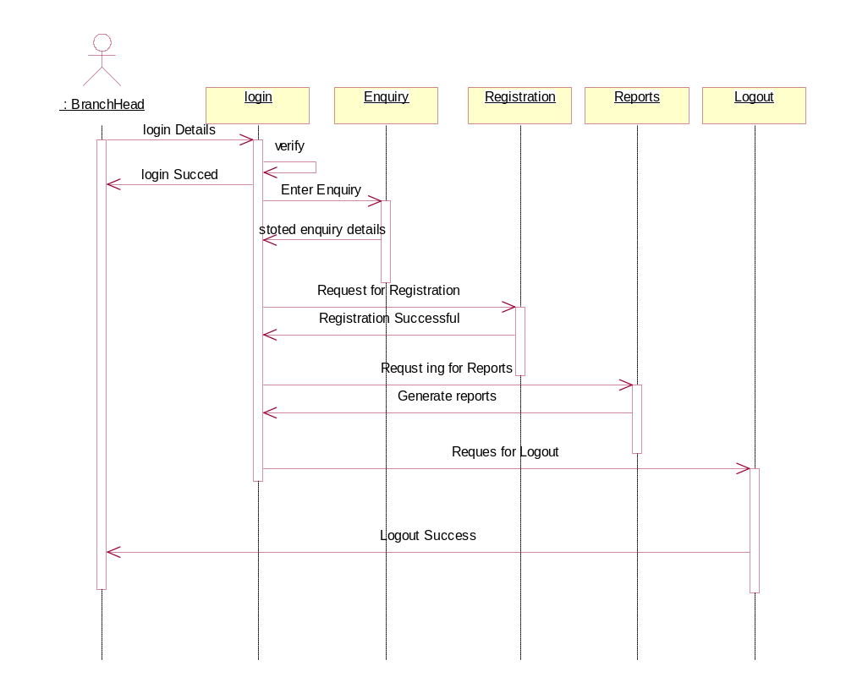

Collaboration Diagram of Branch Head:

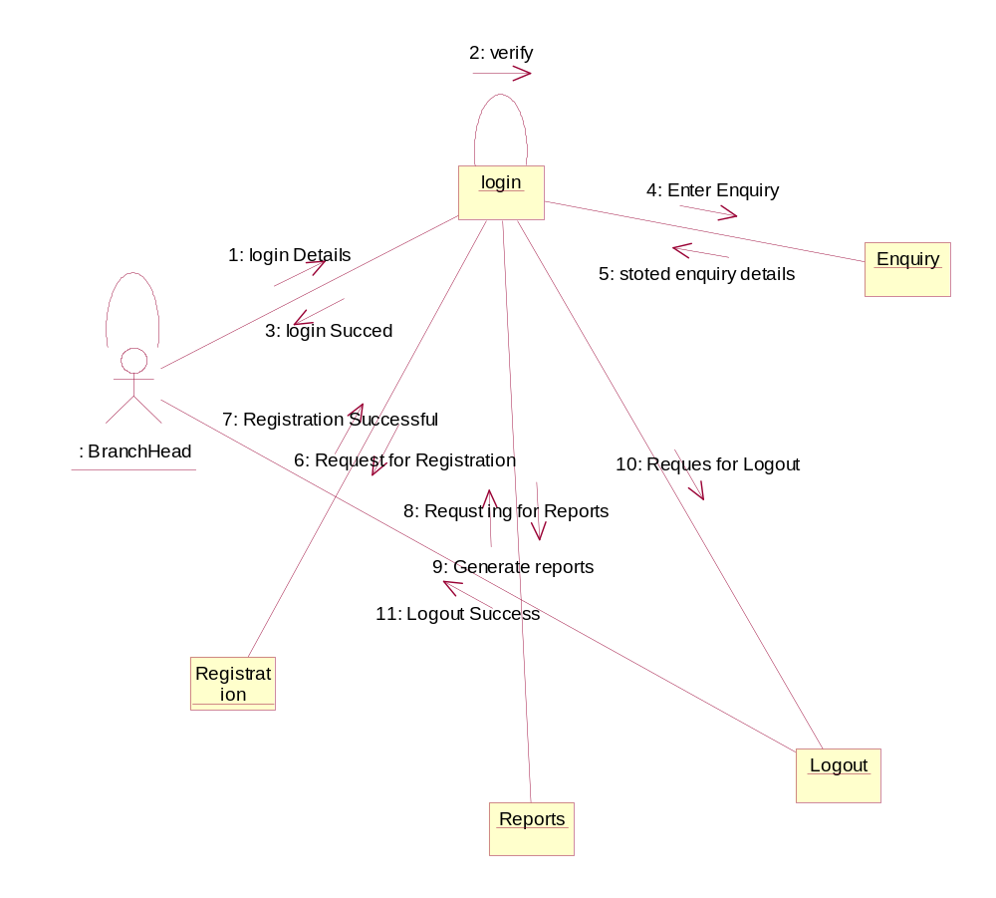

DATA DICTIONARY
Database Design:

Table name: Login

username Varchar2(20) not null
password Varchar2(20) not null

Table name: Branchhead

name Varchar2(20)
username Varchar2(20)
password Varchar2(20)
Phone Number(20)
Jdate Date
Mobile Varchar2(20)
Email Varchar2(20)
Address Varchar2(20)
Branch Varchar2(20)
City Varchar2(20)
Pin Number(6)
State Varchar2(20)
Bno Number(10) Primary Key

Table name: Card

Cno Number(5) Primary Key

Cname Varchar2(10)

Capacity Number
Validity Varchar2(10)
Discount Number
Amount Number

Table name : Enquiry

NAME VARCHAR2(20)
AGE NUMBER
SEX VARCHAR2(10)
DISTRICT VARCHAR2(20)
DESIGNATION VARCHAR2(20)
QUALIFICATION VARCHAR2(20)
STATE VARCHAR2(20)
ADDRESS VARCHAR2(20)
PHONE NUMBER(20)
NSIZE NUMBER(5)
BRANCH VARCHAR2(20)
BDATE DATE

Table name: Reg

CNO NUMBER(5) foreign Key
CNAME VARCHAR2(20)
CAPACITY NUMBER(4)
VALIDITY VARCHAR2(20)
DISCOUNT NUMBER(4)
AMOUNT NUMBER(5)
REGNO NUMBER(5) Primary Key
HNAME VARCHAR2(20)
DESIGNATION VARCHAR2(20)
SEX VARCHAR2(10)
PHONE NUMBER(10)
BRANCH VARCHAR2(20)
QUALIFICATION VARCHAR2(20)
ADDRESS VARCHAR2(20)
PIN NUMBER(10)
STATE VARCHAR2(20)
JDATE DATE
DISTRICT VARCHAR2(20)

Table name: Regdesc

REGNO NUMBER Foeign Key
NAME1 VARCHAR2(20)
SEX1 VARCHAR2(7)
AGE1 NUMBER
RELATION VARCHAR2(20)

TECHNICAL NOTES:
OVERVIEW OF JAVA TECHNOLOGY
Java, whether you love it, or hate it, it's here to stay. Like everyone's favorite language C, Java has had a major impact on the computing scene. When the history of computers is written, its name will be up there with the stars.
If you were to choose just one language to learn today, it should be Java. It's being pushed aggressively by Sun and is growing by leaps and bounds. There are lots of Java programmers out there and more join the party every day.
Java started out as a bit of an accident. A team under Bill Joy was working at Sun on a new programming language for embedded applications. Java was originally expected to work in toasters and fridges, not on modern computers! The initial prognosis for Java was not good and it was only the rise of the Internet which saved Java from oblivion. Since then, neither the Net nor Sun nor Java has looked back and all have grown from strength to strength.
World wide web is an open ended information retrieval system designed to be used in the distributed environment. This system contains web pages that provide both information and controls. We can navigate to a new web page in any direction. This is made possible worth HTML java was meant to be used in distributed environment such as internet. So java could be easily incorporated into the web system and is capable of supporting animation graphics , games and other special effect. The web has become more dynamic and interactive with support of java. We can run a java program on remote machine over internet with the support of web .

JAVA ENVIRONMENT
Java environment includes a large no. of tools which are part of the system known as java development kit (JDK) and hundreds of classes, methods, and interfaces grouped into packages forms part of java standard library(JSL).

JAVA ARCHITECTURE
Java architecture provides a portable, robust , high performing environment for development. Java provides portability by compiling the byte codes for the java virtual machine which are then interpreted on each platform by the runtime environment . java also provides stringent compile and runtime checking and automatic memory management in order to ensure solid code .

JAVA VIRTUAL MACHINE
When we compile the code, java compiler creates machine code (byte code) for a hypothetical machine called java virtual machine (jvm). The jvm will execute the byte code and overcomes the issue of portability . the code is written and compile for one machine and interpreted all other machines . this machine is called java virtual machine .

PARADIGM OF JAVA
- Dynamic down loading applets(small application programs);
- Elimination of flatware phenomenon that is providing those features of a product that user needs at a time. The remaining features of a product can remain in the server.
- Changing economic model of the software
- Up-to-date software availability
- Supports network entire computing

ABOUT HTML
HTML (hyper text markup language) is a language used to create hyper text documents that have hyper links embedded in them . it consists of tags embedded in the text of a document with HTML. We can build web pages or web document s. it is basically a formatting language and not a programming language. The browser reading the document interprets mark up tags to help format the document for subsequent display to a reader. HTML is a language for describing structured documents. HTML is a platform independent. WWW(world wide web) pages are written using HTML. HTML tags control in part the representation of the WWW page when view with web browser. The browser interpretes HTML tags in the web document and displays it. Different browsers show data differently. Examples of browsers used to be web pages include:
- Netscape
- Internet Explorer

JAVA SCRIPT
Java script is a general purpose , prototype based , object oriented scripting language developed jointly by sun and netscape and is meant for the WWW . it is designed to be embedded in diverse applications and systems , with out consuming much memory . java script borrows most of its syntax from java but also inherits from awk and perl , with some indirect influence from self in its object prototype system.
Java scripts dynamically typed that is programs donot declare variable types, and the type of variable is unrestricted and can change at runtime . source can be generated at run time and evaluated against an arbitrary scope. Typical implementations compile by translating source into a specified byte code format, to check syntax and source consistency. Note that the availability to generate and interprate programs at runtime implies the presence of a compiler at runtime.
Java script is a high level scripting language that does not depend on or expose particular machine representations or operating system services. It provides automatic storage management, typically using a garbage collector.

FEATURES:
- Java script is embedded into HTML documents and is executed with in them.
- Java script is browser dependent
- Javascript is an interpreted languaged that can be interpreted by the browser at run time .
- Java script is loosely typed language
- Java script is an object based language.
- Java script is an Eent-Driven language and supports event handlers to specify the functionality of a button.

ADVANTAGES
  - java script can be used for client side application
  - java script provides means to contain multiframe windows for presentation of the web.
  - java script provides basic data validation before it is sent to the server. Eg : login and password checking or whether the values entered are correct or whether all fields in a from are filled and reduced network traffic
  - it creates interactive forms and client side lookup tables .

JavaDataBaseConnectivity(JDBC)

Overview of New Features

Result set enhancements

The JDBC 1.0 API provided result sets that had the ability to scroll in a forward direc-tiononly. Scrollable result sets allow for more flexibility in the processing of results by
providing both forward and backward movement through their contents. In addition,
scrollable result sets allow for relative and absolute positioning. For example, it’s pos-sible to move to the fourth row in a scrollable result set directly, or to move directly to
the third row following the current row, provided the row exists. The JDBC API allows result sets to be directly updatable, as well.

Batch updates

The batch update feature allows an application to submit multiple update statements
(insert/update/delete) in a single request to the database. This can provide a dramatic
increase in performance when a large number of update statements need to be executed.

Advanced data types
Increased support for storing persistent Java programming language objects (Java ob-jects)
and a mapping for SQL99 data types such as binary large objects, and structured
types, has been added to the JDBC API. An application may also customize the map-ping
of SQL99 structured types into Java programming language classes.

Rowsets

As its name implies, a rowset encapsulates a set of rows. A rowset may or may not
maintain an open database connection. When a rowset is ‘disconnected’ from its data
source, updates performed on the rowset are propagated to the underlying database us-ing
an optimistic concurrency control algorithm.Rowsets add support to the JDBC API for the JavaBeans component model. A rowset object is a bean. A rowset implementation may be serializable. Rowsets can be created at design time and used in conjunction with other JavaBeans components in a visual builder tool to construct an application.

JNDI for naming databases

The Java Naming and Directory Interface (JNDI) API can be used in addition to a
JDBC technology-based driver manager (JDBC driver manager) to obtain a connection
to a database. When an application uses the JNDI API, it specifies a logical name that
identifies a particular database instance and JDBC driver for accessing that database.
This has the advantage of making the application code independent of a particular
JDBC driver and JDBC technology URL.

Connection Pooling

The JDBC API contains ‘hooks’ that allow connection pooling to be implemented on
top of the JDBC driver layer. This allows for a single connection cache that spans the
different JDBC drivers that may be in use. Since creating and destroying database con-nectionsis expensive, connection pooling is important for achieving good performance,
especially for server applications.

Distributed transaction support

Support for distributed transactions has been added as an extension to the JDBC API.
This feature allows a JDBC driver to support the standard 2-phase commit protocol
used by the Java Transaction Service (JTS) API.

Other new features

Support for character streams has been added. This means that character data can be re-trieved and sent to the database as a stream of internationalized Unicode characters.
Methods to allow java.math.BigDecimal values to be returned with full precision
have also been added. Support for time zones has been added.

What’s Actually Changed

A New Package

The JDBC API has been factored into two complementary components. The first com-ponent is API that is core to the Java platform (the core JDBC 2.1 API ) and comprises
the updated contents of the java.sql package. This document contains the specifica-tion for the core JDBC 2.1 API. The second component, termed the JDBC 2.0 Optional
Package API, comprises the contents of a new package, javax.sql, which as its name
implies will be delivered as an optional package to the Java platform (formerly Java
Standard Extension). The JDBC 2.0 Optional Package API is described in a separate
document. The java.sql package contains all of the additions that have been made to the existing interfaces and classes, in addition to a few new classes and interfaces. The new jav-ax.sql package has been introduced to contain the parts of the JDBC API which are closely related to other pieces of the Java platform that are themselves Optional Pack-ages. such as the Java Naming and Directory Interface (JNDI), and the Java Transaction Service (JTS).

In addition, some advanced features that are easily separable from the core JDBC API, such as connection pooling and rowsets, have also been added to jav-ax.sql. Putting these advanced facilities into an optional package instead of into core will help keep the core JDBC API small and focused. Since optional packages are downloadable, it will always be possible to deploy an ap-plication which uses the features in the JDBC Optional Package that will “run any-where,” since if an optional package isn’t installed on a client machine, it can be downloaded along with the application that uses it.

Changes to Classes and Interfaces

The list below contains all of the JDBC 2.1 API core classes and interfaces. Interfaces
and classes that are new are listed in bold type. All of the interfaces and classes present
in the JDBC 1.0 API are also present in the core JDBC 2.1 API, however, some of the JDBC 1.0 technology interfaces have gained additional methods. The interfaces that contain new methods are listed in italics and those that have not changed are in normal type.
The separate core JDBC 2.1 API documentation contains the Java programming language definitions of the java.sql interfaces and classes listed above.

Result Set Enhancements
This chapter discusses the new functionality that has been added to result sets. The goal
of the enhancements is to add two new basic capabilities to result sets: scrolling and up-datability.Several methods have also been added to enable a JDBC driver to deliver im-proved performance when processing results. A variety of examples are included to
illustrate the new features.

Scrolling

A result set created by executing a statement may support the ability to move backward
(last-to-first) through its contents, as well as forward (first-to-last). Result sets that sup-portthis capability are called scrollable result sets. Result sets that are scrollable also
support relative and absolute positioning. Absolute positioning is the ability to move
directly to a row by specifying its absolute position in the result set, while relative po-sitioning gives the ability to move to a row by specifying a position that is relative to
the current row. The definition of absolute and relative positioning in the JDBC API is
modeled on the X/Open SQL CLI specification.

Result Set types

The JDBC 1.0 API provided one result set type—forward-only. The JDBC 2.1 core API
provides three result set types: forward-only, scroll-insensitive, and scroll-sensitive. As
their names suggest, the new result set types support scrolling, but they differ in their
ability to make changes visible while they are open.

A scroll-insensitive result set is generally not sensitive to changes that are made while
it is open. A scroll-insensitive result set provides a static view of the underlying data it
contains. The membership, order, and column values of rows in a scroll-insensitive re-sultset are typically fixed when the result set is created. On the other hand, a scroll-sensitive result set is sensitive to changes that are made while it is open, and provides a ‘dynamic’ view of the underlying data. For example, when using a scroll-sensitive result set, changes in the underlying column values of rows are visible. The membership and ordering of rows in the result set may be fixed—this is implementation defined.

Concurrency types

An application may choose from two different concurrency types for a result set: read-only and updatable. A result set that uses read-only concurrency does not allow updates of its contents. This can increase the overall level of concurrency between transactions, since any number of read-only locks may be held on a data item simultaneously.
A result set that is updatable allows updates and may use database write locks to me-diate access to the same data item by different transactions. Since only a single write
lock may be held at a time on a data item, this can reduce concurrency. Alternatively,
an optimistic concurrency control scheme may be used if it is thought that conflicting accesses to data will be rare. Optimistic concurrency control implementations typically
compare rows either by value or by a version number to determine if an update conflict
has occurred.

Performance

Two performance hints may be given to a JDBC 2.1 technology-enabled driver to make
access to result set data more efficient. Specifically, the number of rows to be fetched
from the database each time more rows are needed can be specified, and a direction for
processing the rows—forward, reverse, or unknown—can be given as well. These val-ues
can be changed for an individual result set at any time. A JDBC driver may ignore
a performance hint if it chooses.

Creating a result set

The example below illustrates creation of a result set that is forward-only and uses read-only concurrency. No performance hints are given by the example, so the driver is free
to do whatever it thinks will result in the best performance. The transaction isolation
level for the connection is not specified, so the default transaction isolation level of the
underlying database is used for the result set that is created. Note that this code is just
written using the JDBC 1.0 API, and that it produces the same type of result set that
would have been produced by the JDBC 1.0 API.

Connection con = DriverManager.getConnection("jdbc:my_subprotocol:my_subname");
Statement stmt = con.createStatement();
ResultSet rs = stmt.executeQuery("SELECT emp_no, salary FROM mployees");

The next example creates a scrollable result set that is updatable and sensitive to
updates. Rows of data are requested to be fetched twenty-five at-a-time from the database.

Connection con = DriverManager.getConnection("jdbc:my_subprotocol:my_subname");
Statement stmt = con.createStatement(ResultSet.TYPE_SCROLL_SENSITIVE,
ResultSet.CONCUR_UPDATABLE);

stmt.setFetchSize(25);
ResultSet rs = stmt.executeQuery("SELECT emp_no,salary FROM employees");

The example below creates a result set with the same attributes as the previous example,
however, a prepared statement is used to produce the result set.

PreparedStatement pstmt = con.prepareStatement("SELECT emp_no, salary FROM employees where emp_no = ?",
ResultSet.TYPE_SCROLL_SENSITIVE,
ResultSet.CONCUR_UPDATABLE);

pstmt.setFetchSize(25);
pstmt.setString(1, "100010");
ResultSet rs = pstmt.executeQuery();

The method DatabaseMetaData.supportsResultSetType() can be called to see
which result set types are supported by a JDBC driver. However, an application may
still ask a JDBC driver to create a Statement, PreparedStatement,or CallableStatement object using a result set type that the driver does not support. In this case, the driver should issue an SQLWarning on the Connection that produces the
statement and choose an alternative value for the result set type of the statement accord-ing to the following rules:

1. If an application asks for a scrollable result set type the driver should use a
scrollable type that it supports, even if this differs from the exact type requested
by the application.
2. If the application asks for a scrollable result set type and the driver does not
support scrolling, then the driver should use a forward-only result set type.
Similarly, the method DatabaseMetaData.supportsResultSetConcurrency() can
be called to determine which concurrency types are supported by a driver. If an appli-cation asks a JDBC driver for a concurrency type that it does not support then the driver
should issue an SQLWarning on the Connection that produces the statement and
choose the alternative concurrency type. The choice of result set type should be made
first if an application specifies both an unsupported result set type and an unsupported
concurrency type.

In some instances, a JDBC driver may need to choose an alternate result set type or con-currency type for a ResultSet at statement execution time. For example, a SELECT
statement that contains a join over multiple tables may not produce a ResultSet that is
updatable. The JDBC driver should issue an SQLWarning in this case on the Statement,
PreparedStatement,orCallableStatement that produces the ResultSet and
choose an appropriate result set type or concurrency type as described above. An appli-cation may determine the actual result set type and concurrency type of a ResultSet
by calling the ResultSet.getType() and getConcurrency() methods, respectively.

Updates
A result set is updatable if its concurrency type is CONCUR_UPDATABLE. Rows in an
Updatable result set may be updated, inserted, and deleted. The example below updates the first row of a result set. The ResultSet.updateXXX() methods are used to modify the value of an individual column in the current row, but do not update the underlying
database. When the ResultSet.updateRow() method is called the database is updated.
Columns may be specified by name or number.

rs.first();
rs.updateString(1, "100020");
rs.updateFloat(“salary”, 10000.0f);
rs.updateRow();

The updates that an application makes must be discarded by a JDBC driver if the appli-cationmoves the cursor from the current row before calling updateRow(). In addition,
an application can call the ResultSet.cancelRowUpdates() method to explicitly
cancel the updates that have been made to a row. The cancelRowUpdates() method
must be called after calling updateXXX() and before calling updateRow(), otherwise
it has no effect.

The following example illustrates deleting a row. The fifth row in the result set is de-leted
from the database.

rs.absolute(5);
rs.deleteRow();

The example below shows how a new row may be inserted into a result set. The JDBC
API defines the concept of an insert row that is associated with each result set and is
used as a staging area for creating the contents of a new row before it is inserted into
the result set itself. The ResultSet.moveToInsertRow() method is used to position
the result set’s cursor on the insert row. The ResultSet.updateXXX()and ResultSet.
getXXX() methods are used to update and retrieve individual column values from
the insert row. The contents of the insert row is undefined immediately after calling
ResultSet.

moveToInsertRow(). In other words, the value returned by calling a ResultSet.
getXXX() method is undefined after moveToInsertRow() is called until the
value is set by calling ResultSet.updateXXX(). Calling ResultSet.updateXXX() while on the insert row does not update the underlying database or the result set.
Once all of the column values are set in the insert row, ResultSet.insertRow() is called to update the result set and the database simulta-neously.
If a column is not given a value by calling updateXXX() while on the insert
row, or a column is missing from the result set, then that column must allow a null value.
Otherwise, calling insertRow() throws an SQLException.

rs.moveToInsertRow();
rs.updateString(1, "100050");
rs.updateFloat(2, 1000000.0f);
rs.insertRow();
rs.first();

A result set remembers the current cursor position “in the result set” while its cursor is
temporarily positioned on the insert row. To leave the insert row, any of the usual cursor
positioning methods may be called, including the special method Result-Set.
moveToCurrentRow() which returns the cursor to the row which was the current
row before ResultSet.moveToInsertRow() was called. In the example above,
ResultSet.first() is called to leave the insert row and move to the first row of the
resultset.
Due to differences in database implementations, the JDBC API does not specify an ex-act
set of SQL queries which must yield an updatable result set for JDBC drivers that
support updatability. Developers can, however, generally expect queries which meet
the following criteria to produce an updatable result set:

1. The query references only a single table in the database.
2. The query does not contain any join operations.
3. The query selects the primary key of the table it references.
In addition, an SQL query should also satisfy the conditions listed below if inserts are
to be performed.
4. The query selects all of the non-nullable columns in the underlying table.
5. The query selects all columns that don’t have a default value.

Introduction to Servlets
Servlets provide a Java^{(TM)}-based solution used to address the problems currently associated with doing server-side programming, including inextensible scripting solutions, platform-specific APIs, and incomplete interfaces.
Servlets are objects that conform to a specific interface that can be plugged into a Java-based server. Servlets are to the server-side what applets are to the client-side -- object bytecodes that can be dynamically loaded off the net. They differ from applets in that they are faceless objects (without graphics or a GUI component). They serve as platform-independent, dynamically-loadable, pluggable helper bytecode objects on the server side that can be used to dynamically extend server-side functionality.

What is a Servlet?
Servlets are modules that extend request/response-oriented servers, such as Java-enabled web servers. For example, a servlet might be responsible for taking data in an HTML order-entry form and applying the business logic used to update a company's order database.
Servlets are to servers what applets are to browsers. Unlike applets, however, servlets have no graphical user interface.
Servlets can be embedded in many different servers because the servlet API, which you use to write servlets, assumes nothing about the server's environment or protocol. Servlets have become most widely used within HTTP servers; many web servers support the Servlet API.

Use Servlets instead of CGI Scripts!
Servlets are an effective replacement for CGI scripts. They provide a way to generate dynamic documents that is both easier to write and faster to run. Servlets also address the problem of doing server-side programming with platform-specific APIs: they are developed with the Java Servlet API, a standard Java extension.
So use servlets to handle HTTP client requests. For example, have servlets process data POSTed over HTTPS using an HTML form, including purchase order or credit card data. A servlet like this could be part of an order-entry and processing system, working with product and inventory databases, and perhaps an on-line payment system.

Other Uses for Servlets
Here are a few more of the many applications for servlets:
- Allowing collaboration between people. A servlet can handle multiple requests concurrently, and can synchronize requests. This allows servlets to support systems such as on-line conferencing.
- Forwarding requests. Servlets can forward requests to other servers and servlets. Thus servlets can be used to balance load among several servers that mirror the same content, and to partition a single logical service over several servers, according to task type or organizational boundaries.

Architecture of the Servlet Package
The javax.servlet package provides interfaces and classes for writing servlets. The architecture of the package is described below.

The Servlet Interface
The central abstraction in the Servlet API is the Servlet interface. All servlets implement this interface, either directly or, more commonly, by extending a class that implements it such as HttpServlet.

The Servlet interface declares, but does not implement, methods that manage the servlet and its communications with clients. Servlet writers provide some or all of these methods when developing a servlet.

Client Interaction
When a servlet accepts a call from a client, it receives two objects:
- A ServletRequest, which encapsulates the communication from the client to the server.
- A ServletResponse, which encapsulates the communication from the servlet back to the client.
ServletRequest and ServletResponse are interfaces defined by the javax.servlet package.

The ServletRequest Interface
The ServletRequest interface allows the servlet access to:
- Information such as the names of the parameters passed in by the client, the protocol (scheme) being used by the client, and the names of the remote host that made the request and the server that received it.
- The input stream, ServletInputStream. Servlets use the input stream to get data from clients that use application protocols such as the HTTP POST and PUT methods.
Interfaces that extend ServletRequest interface allow the servlet to retrieve more protocol-specific data. For example, the HttpServletRequest interface contains methods for accessing HTTP-specific header information.

The ServletResponse Interface
The ServletResponse interface gives the servlet methods for replying to the client. It:
- Allows the servlet to set the content length and MIME type of the reply.
- Provides an output stream, ServletOutputStream, and a Writer through which the servlet can send the reply data.
Interfaces that extend the ServletResponse interface give the servlet more protocol-specific capabilities. For example, the HttpServletResponse interface contains methods that allow the servlet to manipulate HTTP-specific header information.

Additional Capabilities of HTTP Servlets
The classes and interfaces described above make up a basic Servlet. HTTP servlets have some additional objects that provide session-tracking capabilities. The servlet writer can use these APIs to maintain state between the servlet and the client that persists across multiple connections during some time period. HTTP servlets also have objects that provide cookies. The servlet writer uses the cookie API to save data with the client and to retrieve this data.

That's it!
The classes mentioned in the Architecture of the Servlet Package section are shown in the example in bold:
- SimpleServlet extends the HttpServlet class, which implements the Servlet interface.
- SimpleServlet overrides the doGet method in the HttpServlet class. The doGet method is called when a client makes a GET request (the default HTTP request method), and results in the simple HTML page being returned to the client.
- Within the doGet method,
  - The user's request is represented by an HttpServletRequest object.
  - The response to the user is represented by an HttpServletResponse object.
  - Because text data is returned to the client, the reply is sent using the Writer object obtained from the HttpServletResponse object.

Servlet Lifecycle
Each servlet has the same life cycle:
- A server loads and initializes the servlet
- The servlet handles zero or more client requests
- The server removes the servlet

Initializing a Servlet
When a server loads a servlet, the server runs the servlet's init method. Initialization completes before client requests are handled and before the servlet is destroyed.
Even though most servlets are run in multi-threaded servers, servlets have no concurrency issues during servlet initialization. The server calls the init method once, when the server loads the servlet, and will not call the init method again unless the server is reloading the servlet. The server can not reload a servlet until after the server has destroyed the servlet by calling the destroy method.
The init Method
The init method provided by the HttpServlet class initializes the servlet and logs the initialization. To do initialization specific to your servlet, override the init() method following these rules:
- If an initialization error occurs that renders the servlet incapable of handling client requests, throw an UnavailableException.

Initialization Parameters
The second version of the init method calls the getInitParameter method. This method takes the parameter name as an argument and returns a String representation of the parameter's value.
The specification of initialization parameters is server-specific. In the Java Web Server, the parameters are specified with a servlet is added then configured in the Administration Tool. For an explanation of the Administration screen where this setup is performed, see the Administration Tool: Adding Servlets online help document.
If, for some reason, you need to get the parameter names, use the getParameterNames method.

Destroying a Servlet
Servlets run until the server are destroys them, for example at the request of a system administrator. When a server destroys a servlet, the server runs the servlet's destroy method. The method is run once; the server will not run that servlet again until after the server reloads and reinitializes the servlet. When the destroy method runs, another thread might be running a service request. The Handling Service Threads at Servlet Termination section shows you how to provide a clean shutdown when there could be long-running threads still running service requests.

Using the Destroy Method
The destroy method provided by the HttpServlet class destroys the servlet and logs the destruction. To destroy any resources specific to your servlet, override the destroy method. The destroy method should undo any initialization work and synchronize persistent state with the current in-memory state.
A server calls the destroy method after all service calls have been completed, or a server-specific number of seconds have passed, whichever comes first. If your servlet handles any long-running operations, service methods might still be running when the server calls the destroy method. You are responsible for making sure those threads complete. The next section shows you how.
The destroy method shown above expects all client interactions to be completed when the destroy method is called, because the servlet has no long-running operations.

Handling Service Threads at Servlet Termination
All of a servlet's service methods should be complete when a servlet is removed. The server tries to ensure this by calling the destroy method only after all service requests have returned, or after a server-specific grace period, whichever comes first. If your servlet has operations that take a long time to run (that is, operations that may run longer than the server's grace period), the operations could still be running when destroy is called. You must make sure that any threads still handling client requests complete; the remainder of this section describes a technique for doing this.
If your servlet has potentially long-running service requests, use the following techniques to:
- Keep track of how many threads are currently running the service method.
- Provide a clean shutdown by having the destroy method notify long-running threads of the shutdown and wait for them to complete
- Have the long-running methods poll periodically to check for shutdown and, if necessary, stop working, clean up and return.
Tracking Service Requests
To track service requests, include a field in your servlet class that counts the number of service methods that are running. The field should have access methods to increment, decrement, and return its value.
The service method should increment the service counter each time the method is entered and decrement the counter each time the method returns. This is one of the few times that your HttpServlet subclass should override the service method. The new method should call super.service to preserve all the original HttpServlet.service method's functionality.

Providing a Clean Shutdown
To provide a clean shutdown, your destroy method should not destroy any shared resources until all the service requests have completed. One part of doing this is to check the service counter. Another part is to notify the long-running methods that it is time to shut down. For this, another field is required along with the usual access methods.

Creating Polite Long-running Methods
The final step in providing a clean shutdown is to make any long-running methods behave politely. Methods that might run for a long time should check the value of the field that notifies them of shut downs, and interrupt their work if neceesary.

Servlet-client Interaction

Handling HTTP Clients
An HTTP Servlet handles client requests through its service method. The service method supports standard HTTP client requests by dispatching each request to a method designed to handle that request. For example, the service method calls the doGet method shown earlier in the simple example servlet.
Requests and Responses
Methods in the HttpServlet class that handle client requests take two arguments:
- An HttpServletRequest object, which encapsulates the data from the client
- An HttpServletResponse object, which encapsulates the response to the client

HttpServletRequest Objects
An HttpServletRequest object provides access to HTTP header data, such as any cookies found in the request and the HTTP method with which the request was made. The HttpServletRequest object also allows you to obtain the arguments that the client sent as part of the request.
To access client data:
- The getParameter method returns the value of a named parameter. If your parameter could have more than one value, use getParameterValues instead. The getParameterValues method returns an array of values for the named parameter. (The method getParameterNames provides the names of the parameters.)
- For HTTP GET requests, the getQueryString method returns a String of raw data from the client. You must parse this data yourself to obtain the parameters and values.
- For HTTP POST, PUT, and DELETE requests,
  - If you expect text data, the getReader method returns a BufferedReader for you to use to read the raw data.
If you expect binary data, the getInputStream method returns a ServletInputStream for you to use to read the raw data

HttpServletResponse Objects
An HttpServletResponse object provides two ways of returning data to the user:
- The getWriter method returns a Writer
- The getOutputStream method returns a ServletOutputStream
Use the getWriter method to return text data to the user, and the getOutputStream method for binary data.
Closing the Writer or ServletOutputStream after you send the response allows the server to know when the response is complete.

HTTP Header Data
You must set HTTP header data before you access the Writer or OutputStream. The HttpServletResponse class provides methods to access the header data. For example, the setContentType method sets the content type. (This header is often the only one manually set.)

Handling GET and POST Requests
The methods to which the service method delegates HTTP requests include,
- doGet, for handling GET, conditional GET, and HEAD requests
- doPost, for handling POST requests
- doPut, for handling PUT requests
- doDelete, for handling DELETE requests
By default, these methods return a BAD_REQUEST (400) error. Your servlet should override the method or methods designed to handle the HTTP interactions that it supports. This section shows you how to implement methods that handle the most common HTTP requests: GET and POST.
The HttpServlet's service method also calls the doOptions method when the servlet receives an OPTIONS request, and doTrace when the servlet receives a TRACE request. The default implementation of doOptions automatically determines what HTTP options are supported and returns that information. The default implementation of doTrace causes a response with a message containing all of the headers sent in the trace request. These methods are not typically overridden.

Threading Issues
HTTP servlets are typically capable of serving multiple clients concurrently. If the methods in your servlet that do work for clients access a shared resource, then you can handle the concurrency by creating a servlet that handles only one client request at a time. (You could also synchronize access to the resource, a general topic in the Java Programming Language that is note covered in this tutorial.)
To have your servlet handle only one client at a time, have your servlet implement the SingleThreadModel interface in addition to extending the HttpServlet class.
Implementing the SingleThreadModel interface does not involve writing any extra methods. You merely declare that the servlet implements the interface, and the server makes sure that your servlet runs only one service method at a time.
For example, the ReceiptServlet accepts a user's name and credit card number, and thanks the user for their order. If this servlet actually updated a database, for example one that kept track of inventory, then the database connection might be a shared resource. The servlet could either synchronize access to that resource, or it could implement the SingleThreadModel interface.

Servlet Descriptions
In addition to handling HTTP client requests, some applications, such as the Java Web Server's Administration Tool, get descriptive information from the servlet and display it. The servlet description is a string that can describe the purpose of the servlet, its author, its version number, or whatever the servlet author deems important.
The method that returns this information is getServletInfo, which returns null by default. You are not required to override this method, but applications are unable to supply a description of your servlet unless you do.

Writing Your First Servlet
Servlets are also easy to develop. This document discusses the following minimum steps needed to create any servlet:
- Write the servlet
  - Import the necessary Java packages
  - Inherit from GenericServlet or the HTTP convenience class HttpServlet
  - Override the service method (this is where the actual work is done by the servlet)
  - Save the file with a .java filename extension
- Compile the servlet
  - Make sure jws.jar is included in your classpath
  - Invoke javac
- Install the servlet
  - Use the Java Web Server's Administration Tool to install it, and optionally configure it.
- Test the servlet
  - Invoke the servlet from a JDK1.1-compatible browser.
We'll discuss each one of these steps in its simplest form.
There are also lots of servlet examples complete with working code.

Write the servlet
The following class completely defines a servlet:
//Import needed Java packages

import java.io.*;
import javax.servlet.*;
import javax.servlet.http.*;

// Create a class which inherits from GenericServlet or HttpServlet.

public class MyFirst extends HttpServlet
{
/**
* Override the service method.
* Here we handle the HTTP GET method by building a simple web page.
*/

public void doGet (HttpServletRequest request,
HttpServletResponse response)
throws ServletException, IOException
{
PrintWriter out;
String title = "MyFirst Servlet Output";

// set content type and other response header fields first
response.setContentType("text/html");

// then write the data of the response
out = response.getWriter();

out.println("<HTML><HEAD><TITLE>");
out.println(title);
out.println("</TITLE></HEAD><BODY>");
out.println("<H1>" + title + "</H1>");
out.println("<P>This is output from MyFirst servlet.");
out.println("</BODY></HTML>");
out.close();
}
}
Don't forget to save the file with the name of the class and a .java filename extension -- in this case, we'll use MyFirst.java.

Compile the servlet
Make sure the compiler will be able to find the jws.jar file. The jws.jar file contains Java Web Server's implementation of the Servlet API. Ensuring the compiler can find the file is easy to do using the cp option to the compiler, as we do below. (You can also modify the classpath environment variable temporarily from a command line or permanently in your system setttings.)
Use javac, located in the Java Web Server's jre/bin directory, to compile the .java file. You'll need to copy the resulting .class file to the servlets directory of the Java Web Server so the web server will automatically find it. To skip the copying step, simply invoke javac with the -d option to direct the resulting .class file to the target directory.
For example, the following command compiles MyFirst.java and stores the resulting MyFirst.class file in the servlets directory:
javac -cp server_root/lib/jws.jar -d server_root/servlets MyFirst.java
where server_root is the directory of the installed Java Web Server.

Install the servlet
The process for installing a servlet into a web server varies from web server to webserver. For the Java Web Server, the procedure is as follows:
- Start the Java Web Server, if it is not already running
- Log in to the Java Web Server on the administration port.
By default, the administration port is 9090 and the username/password is admin/admin. If you are successful, you should see the services page of the AdminTool applet.
- Select the WebPage Service then click the Manage button. This should bring up the Web Service window.
- Click the Servlets button, then select the Add entry in the list in the lefthand pane. You should now see the Add a New Servlet fields in the righthand pane.
- Fill in the fields as follows:
  - Servlet Name: Choose any name you like, it need not be related to the filename. This will be the name used to invoke the servlet. We'll use FirstServlet.
  - Servlet Class: Provide the actual name of the servlet class, not file, you created -- for this example the real name is MyFirst.
  - Click the Add button and you will see your servlet name appear in the list of servlets in the lefthand pane under Configure. The righthand pane will have changed to two tabbed panels -- Configuration and Properties. We won't need these for our simple example so simply close the window.

Test the servlet
If you successfully compiled MyFirst.java and added it to the Java Web Server as described above, you should be able to invoke it from a JDK1.1-compatible browser. Use a URL of the following form:
http://host_name:port/servlet/servlet_name
For example:
http://schnauzer:8080/servlet/FirstServlet
That's it! You've just developed your first servlet.

About Session Tracking
Session T tracking is a flexible, lightweight mechanism that enables stateful programming on the web. Its general implementation serves as a basis for more sophisticated state models, such as persistent user profiles or multi-user sessions.
A session is a series of requests from the same user that occur during a time period. This transaction model for sessions has many benefits over the single-hit model. It can maintain state and user identity across multiple page requests. It can also construct a complex overview of user behavior that goes beyond reporting of user hits.

Server-Side Session Objects and Users
Session tracking gives servlets and other server-side applications the ability to keep state information about a user as the user moves through the site. Server-side applications can use this facility to create more stateful user experiences and to track who's doing what on the site.
Java Web Server maintains user state by creating a Session object for each user on the site. These Session objects are stored and maintained on the server. When a user first makes a request to a site, the user is assigned a new Session object and a unique session ID. The session ID matches the user with the Session object in subsequent requests. The Session object is then passed as part of the request to the servlets that handle the request. Servlets can add information to Session objects or read information from them.

Session Endurance
After the user has been idle for more than a certain period of time (30 minutes by default), the user's session becomes invalid, and the corresponding Session object is destroyed.

A session is a set of requests originating from the same browser, going to the same server, bounded by a period of time. Loosely speaking, a session corresponds to a single sitting of a single anonymous user (anonymous because no explicit login or authentication is required to participate in session tracking).

Using Session Tracking from a Servlet
The following example uses the doGet method from a servlet that prints the number of times users access a particular servlet.
public void doGet (HttpServletRequest request, HttpServletResponse response)
throws ServletException, IOException
{

// Obtain the Session object
HttpSession session = request.getSession (true);

// Get the session data value
Integer ival = (Integer)
session.getValue ("sessiontest.counter");
if (ival == null) ival = new Integer (1);
else ival = new Integer (ival.intValue () + 1);
session.putValue ("sessiontest.counter", ival);

// Output the page
response.setContentType("text/html");
ServletOutputStream out = response.getOutputStream();
out.println("<html>");
out.println("<head><title>Session Tracking Test</title></head>");
out.println("<body>");
out.println("<h1>Session Tracking Test</h1>");
out.println ("You have hit this page " + ival + " times");
out.println("</body></html>");
}
The first part of the doGet method associates the Session object with the user making the request. The second part of the method gets an integer data value from the Session object and increments it. The third part outputs the page, including the current value of the counter.
When run, this servlet should output the value of the counter that increments every time you reload the page. You must obtain the Session object before you actually write any data to the servlet's output stream. This guarantees that the session tracking headers are sent with the response.

Storing and Retrieving Data From the Session Object
You obtain the session data value with the following:
Integer ival = (Integer)
session.getValue ("sessiontest.counter");
if (ival == null) ival = new Integer (1);
else ival = new Integer (ival.intValue () + 1);
session.putValue ("sessiontest.counter", ival);
The Session object has methods similar to java.util.Dictionary for adding, retrieving, and removing arbitrary Java objects. In this example, an Integer object is read from the Session object, incremented, then written back to the Session object.
Any name, such as sessiontest.counter, may be used to identify values in the Session object. When choosing names, remember that the Session object is shared among any servlets that the user might access. Servlets may access or overwrite each other's values from the Session. Thus, it is good practice to adopt a convention for organizing the namespace to avoid collisions between servlets, such as:
servletname.name

Session Invalidation
Sessions can be invalidated automatically or manually. Session objects that have no page requests for a period of time (30 minutes by default) are automatically invalidated by the Session Tracker sessionInvalidationTime parameter. When a session is invalidated, the Session object and its contained data values are removed from the system.
After invalidation, if the user attempts another request, the Session Tracker detects that the user's session was invalidated and creates a new Session object. However, data from the user's previous session will be lost.
Session objects can be invalidated manually by calling Session.invalidate(). This will cause the scession to be invalidated immediately, removing it and its data values from the system.

Handling Non-Cookie Browsers (URL Rewriting)
s The Session Tracker uses a session ID to match users with Session objects on the server side. The session ID is a string that is sent as a cookie to the browser when the user first accesses the server. On subsequent requests, the browser sends the session ID back as a cookie, and the server uses this cookie to find the session associated with that request.
There are situations, however, where cookies will not work. Some browsers, for example, do not support cookies. Other browsers allow the user to disable cookie support. In such cases, the Session Tracker must resort to a second method, URL rewriting, to track the user's session.
URL rewriting involves finding all links that will be written back to the browser, and rewriting them to include the session ID. For example, a link that looks like this:
<a href="/store/catalog">
might be rewritten to look like this:
<a href="/store/catalog;$sessionid$DA32242SSGE2">
If the user clicks on the link, the rewritten form of the URL will be sent to the server. The server's Session Tracker will be able to recognize the ;$sessionid$DA32242SSGE2 and extract it as the session ID. This is then used to obtain the proper Session object.
Implementing this requires some reworking by the servlet developer. Instead of writing URLs straight to the output stream, the servlet should run the URLs through a special method before sending them to the output stream. For example, a servlet that used to do this:
out.println("<a href=\"/store/catalog\">catalog</a>");
should now do this:
out.print ("<a href=\"");
out.print (response.encodeUrl ("/store/catalog"));
out.println ("\">catalog</a>");
The encodeUrl method performs two functions:
- Determine URL Rewriting: The encodeUrl method determines if the URL needs to be rewritten. Rules for URL rewriting are somewhat complex, but in general if the server detects that the browser supports cookies, then the URL is not rewritten. The server tracks information indicating whether a particular user's browser supports cookies.
- Return URL (modified or the same): If the encodeUrl method determined that the URL needs to be rewritten, then the session ID is inserted into the URL and returned. Otherwise, the URL is returned unmodified.
In addition to URLs sent to the browser, the servlet must also encode URLs that would be used in sendRedirect() calls. For example, a servlet that used to do this:
response.sendRedirect ("http://myhost/store/catalog");
should now do this:
response.sendRedirect
(response.encodeRedirectUrl ("http://myhost/store/catalog"));
The methods encodeUrl and encodeRedirectUrl are distinct because they follow different rules for determining if a URL should be rewritten.
Multiple Servlets
URL conversions are required only if the servlet supports session tracking for browsers that do not support cookies or browsers that reject cookies. The consequences of not doing these conversions is that the user's session will be lost if the user's browser does not support cookies and the user clicks on an un-rewritten URL. Note that this can have consequences for other servlets. If one servlet does not follow these conventions, then a user's session could potentially be lost for all servlets.

Using Session Tracking with the Page Compiler
Page compilation is a feature of the Java Web Server that allows HTML pages containing Java code to be compiled and run as servlets. Page compilation also simplifies the task of supporting session tracking. To that end, if URL rewriting is enabled, page compilation automatically adds the encodeUrl call to links in the HTML page.
For example, the Access Count Example could be rewritten as a .jhtml file like this:
<html>
<head><title>Session Tracking Test</title></head>
<body>
<h1>Session Tracking Test</h1>

<java type=import>javax.servlet.http.*</java>

<java>
HttpSession session = request.getSession (true);

// Get the session data value
Integer ival = (Integer)
session.getValue ("sessiontest.counter");
if (ival == null) ival = new Integer (1);
else ival = new Integer (ival.intValue () + 1);
session.putValue ("sessiontest.counter", ival);
</java>

You have hit this page <java type=print>ival</java> times.

<p>Click here to go to the <a href="/store/catalog">catalog</a>

</body></html>
This example is similar to the servlet code in the previous example, except that the Java code has been inserted directly into the HTML source. In this example, the /store/catalog link will be detected by the Page Compiler and will automatically call encodeUrl.

Screens and Reports

e-Learn screens

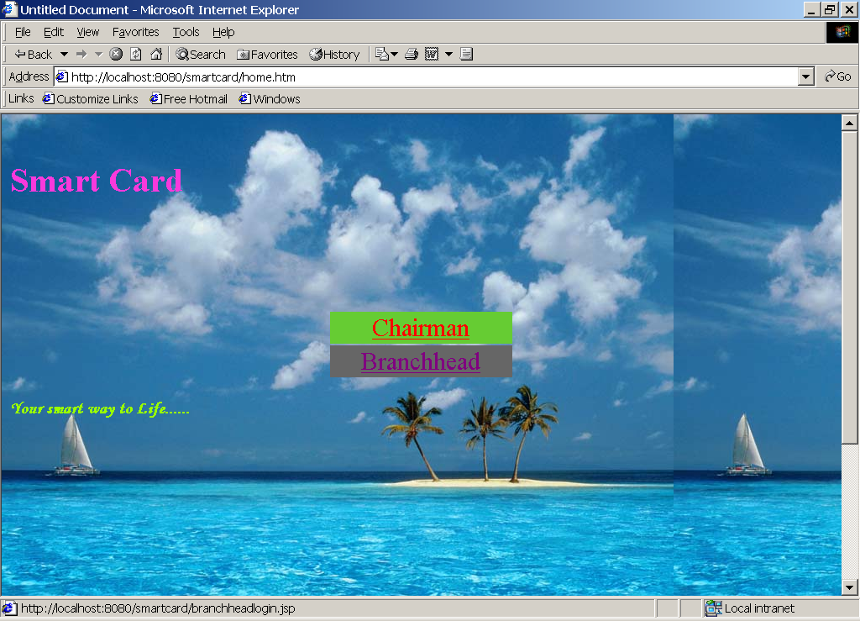

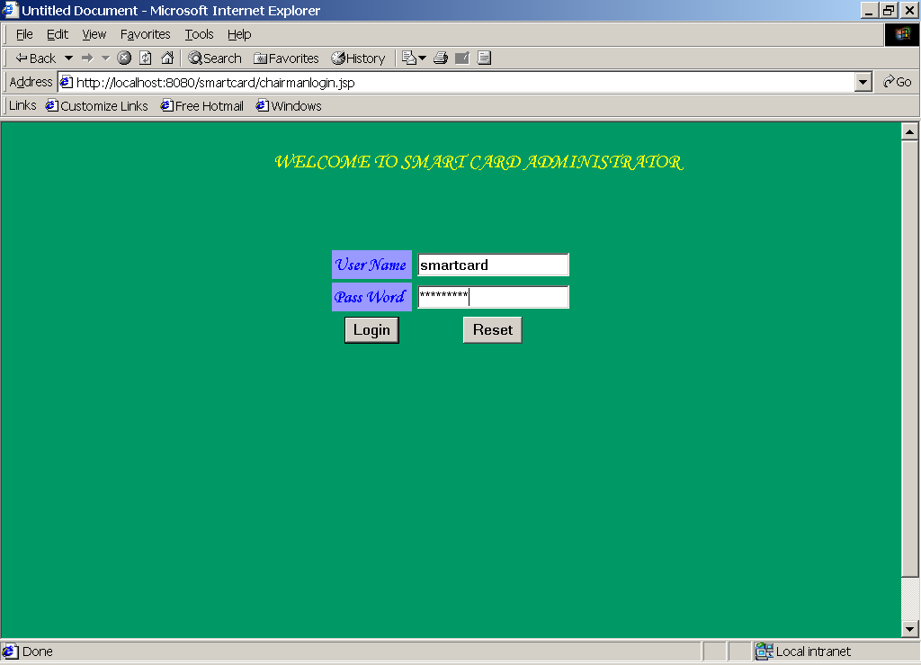

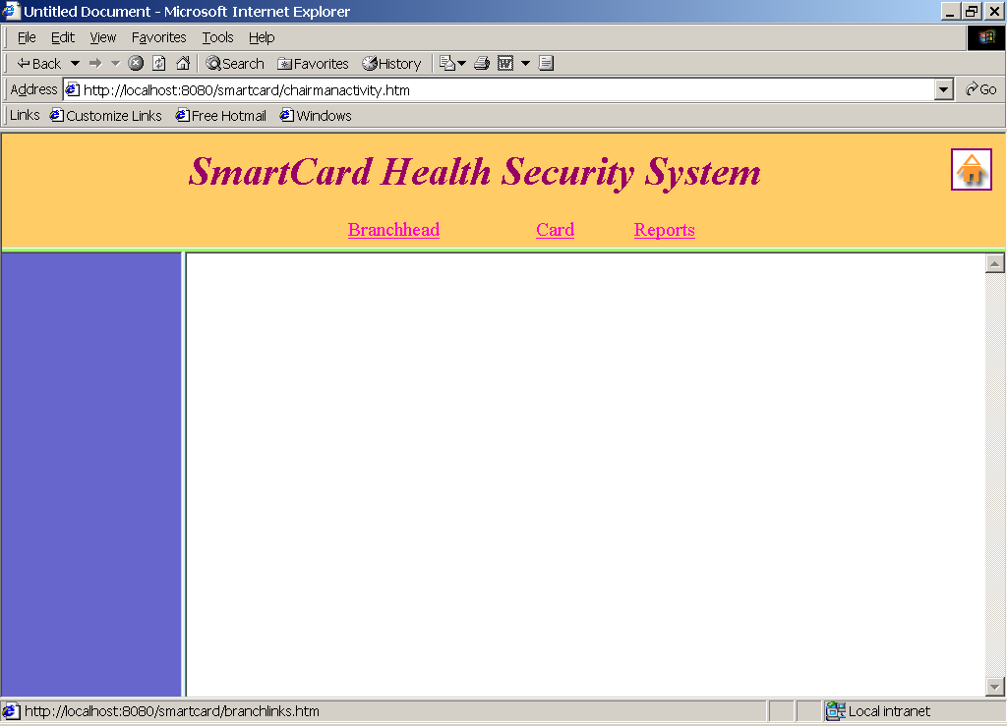

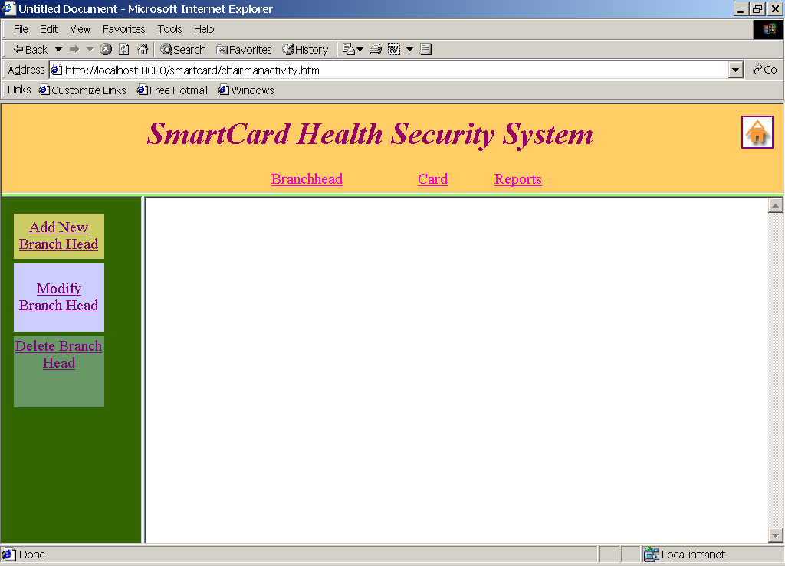

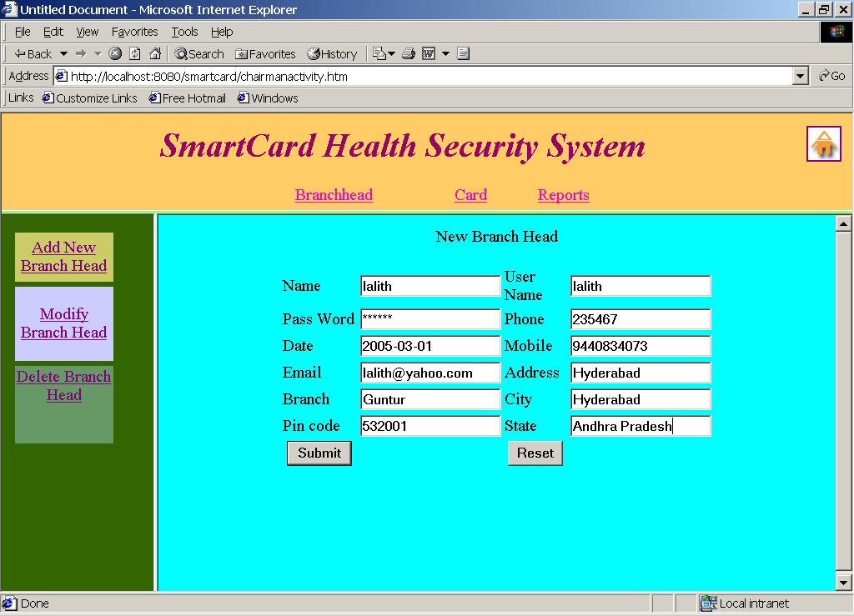

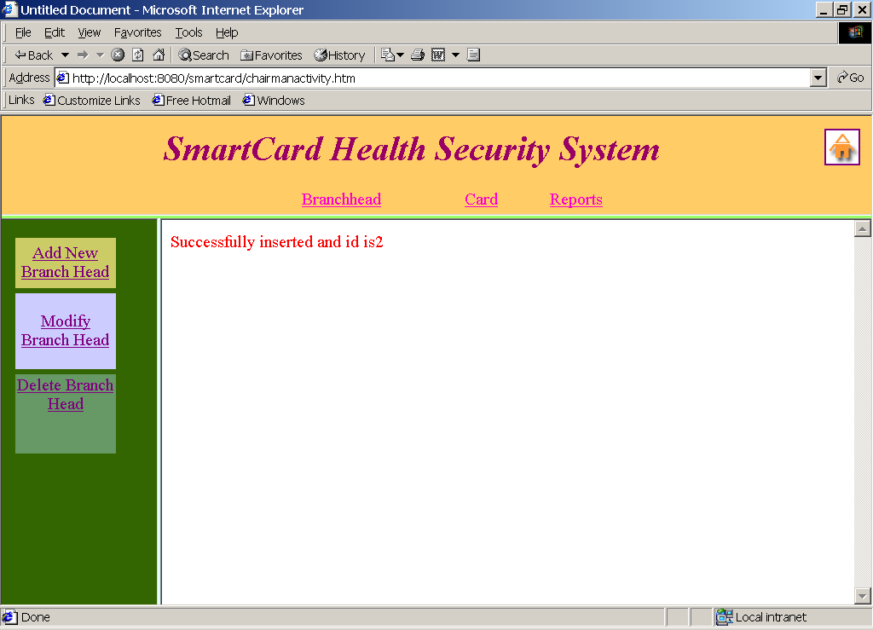

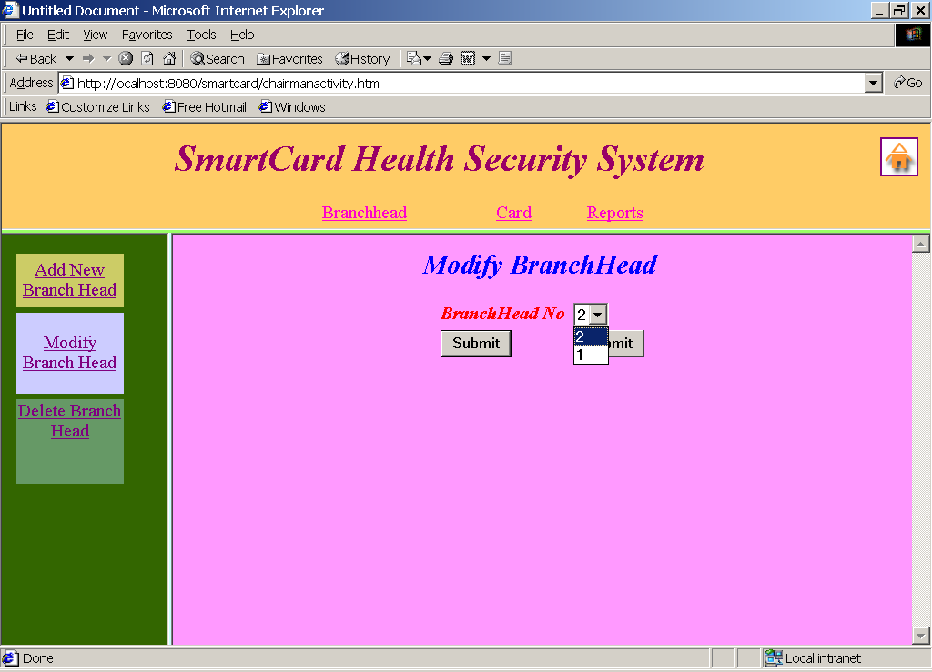

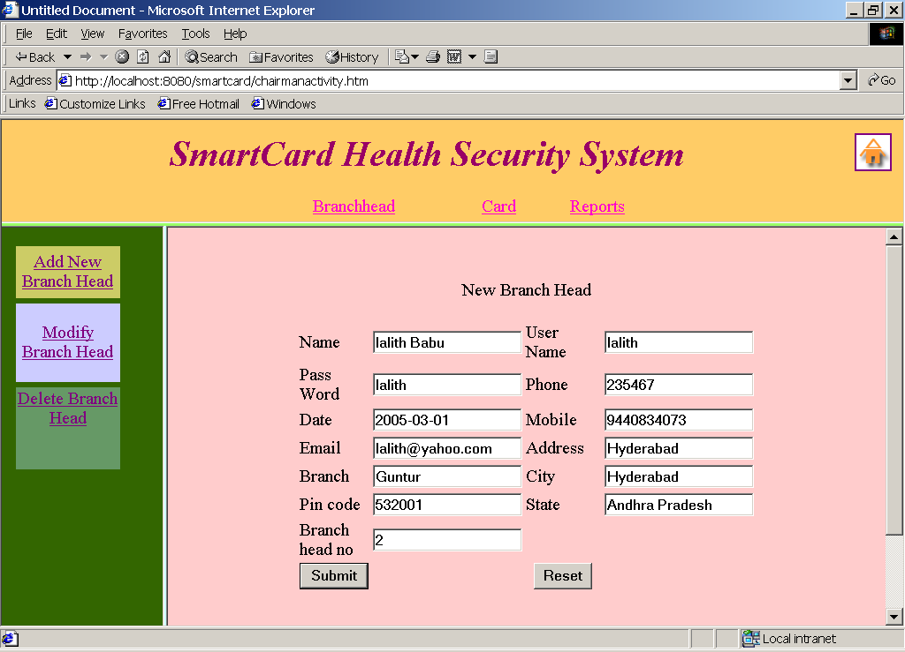

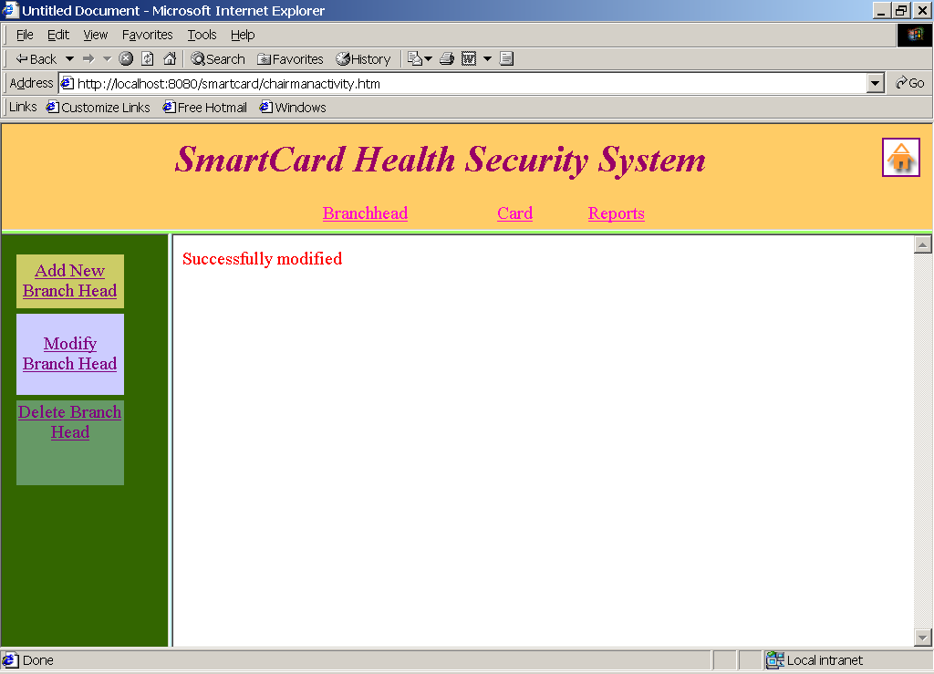

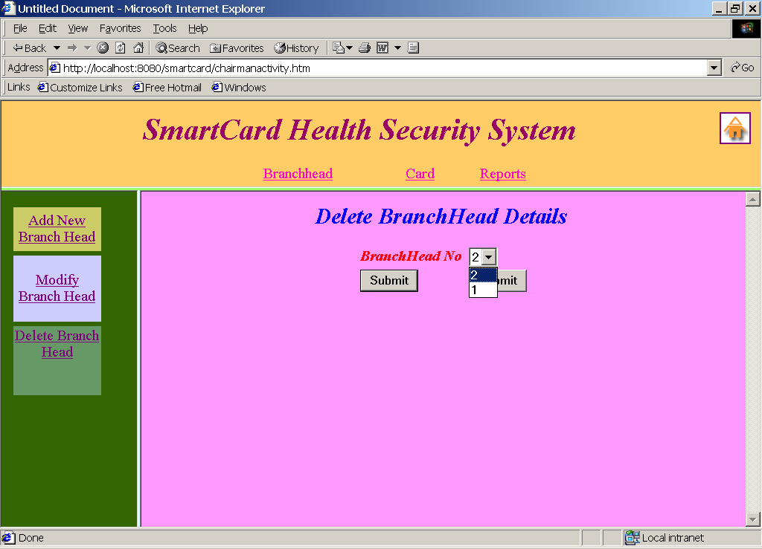

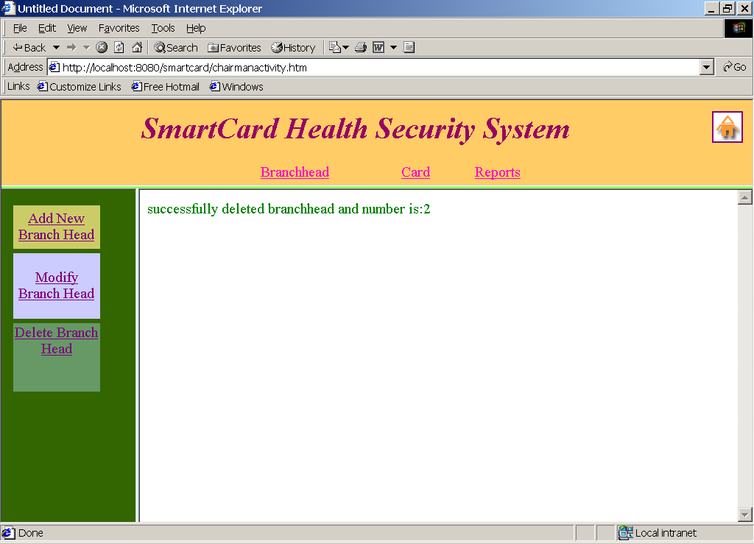

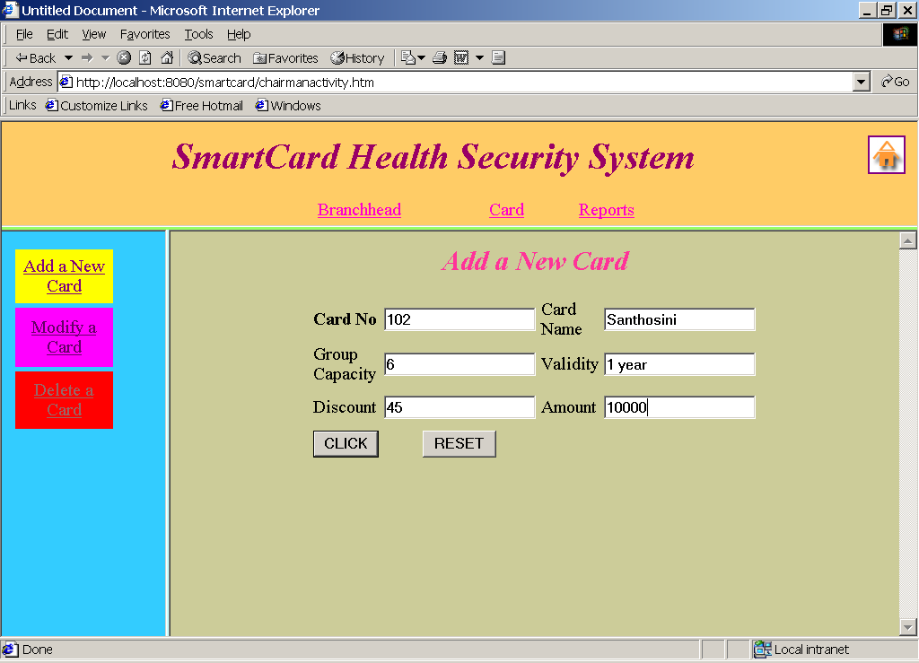

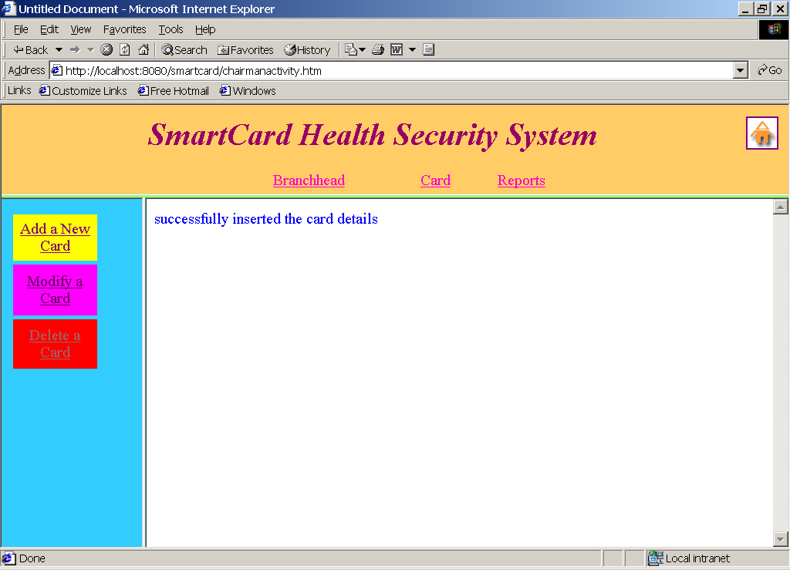

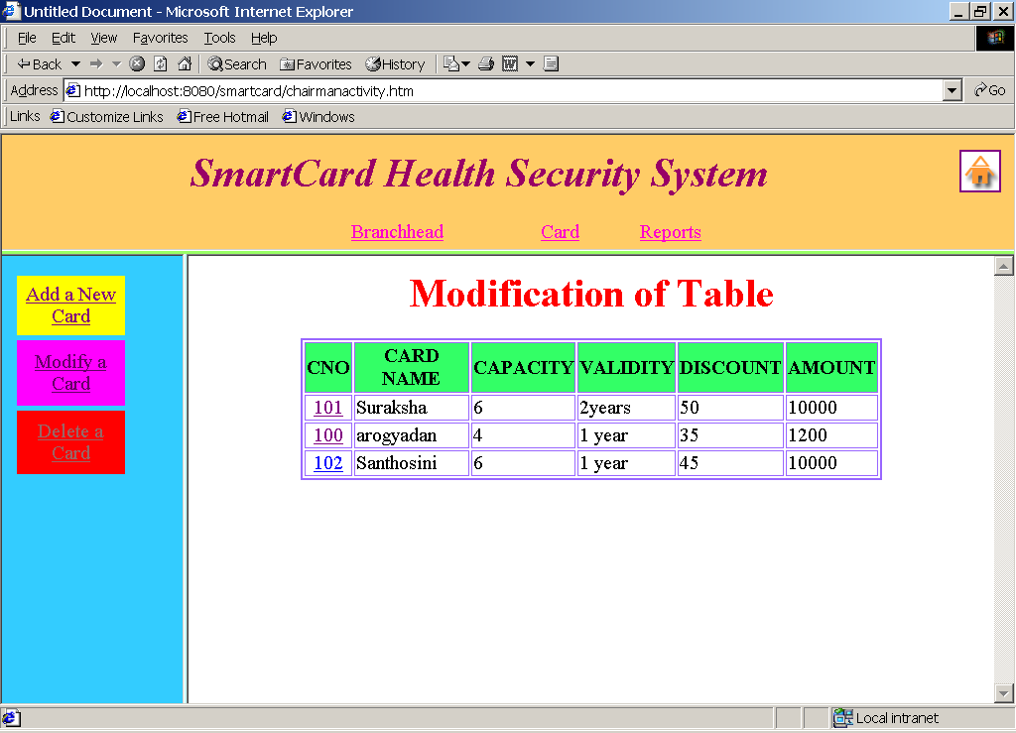

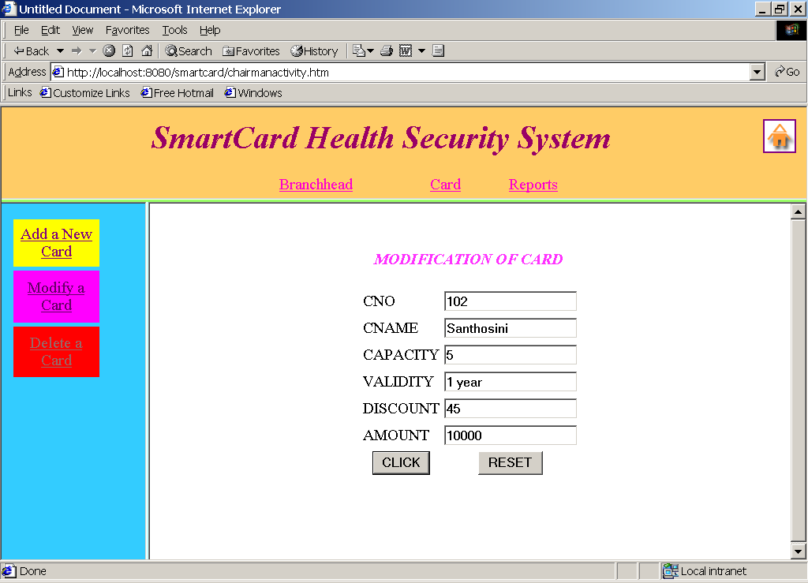

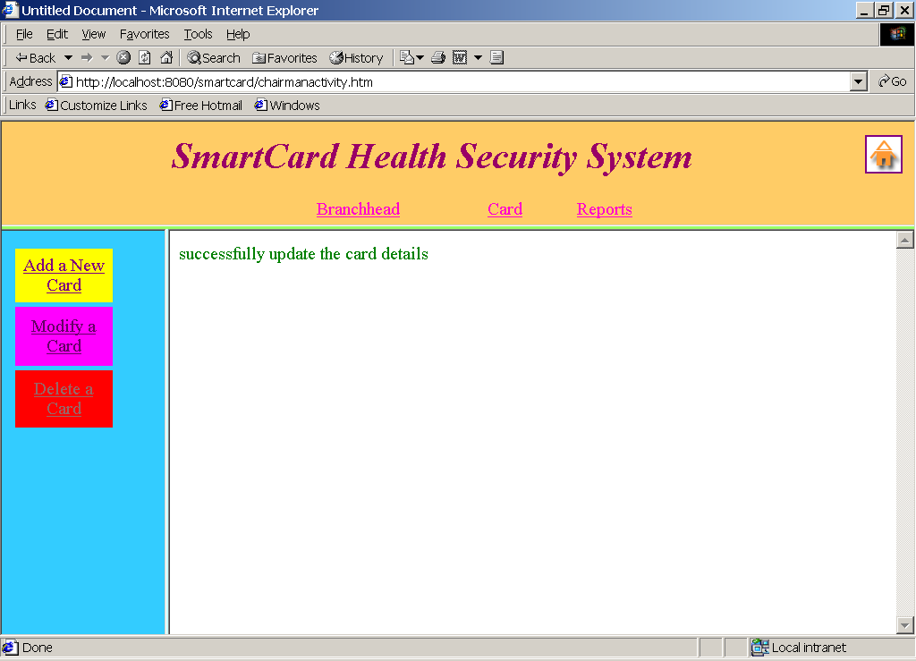

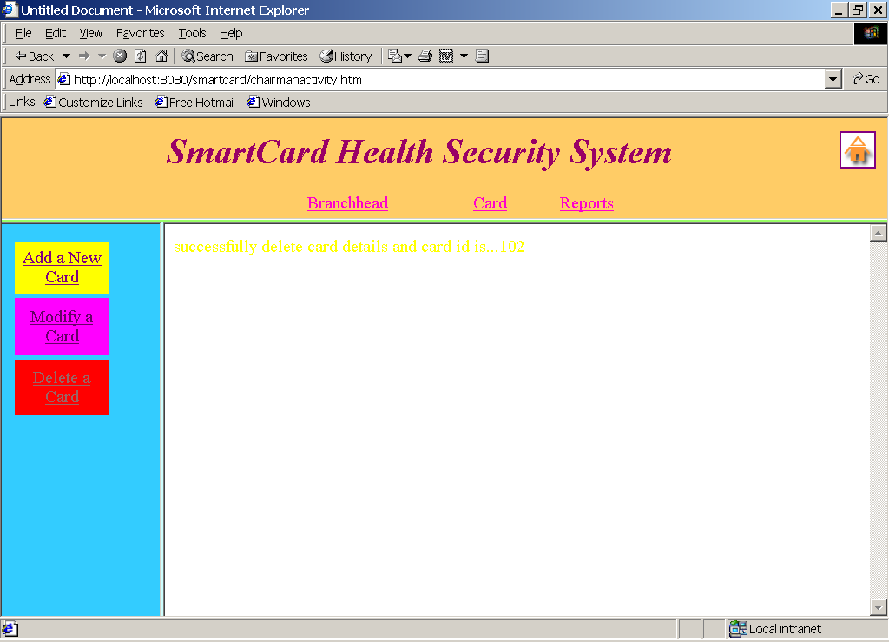

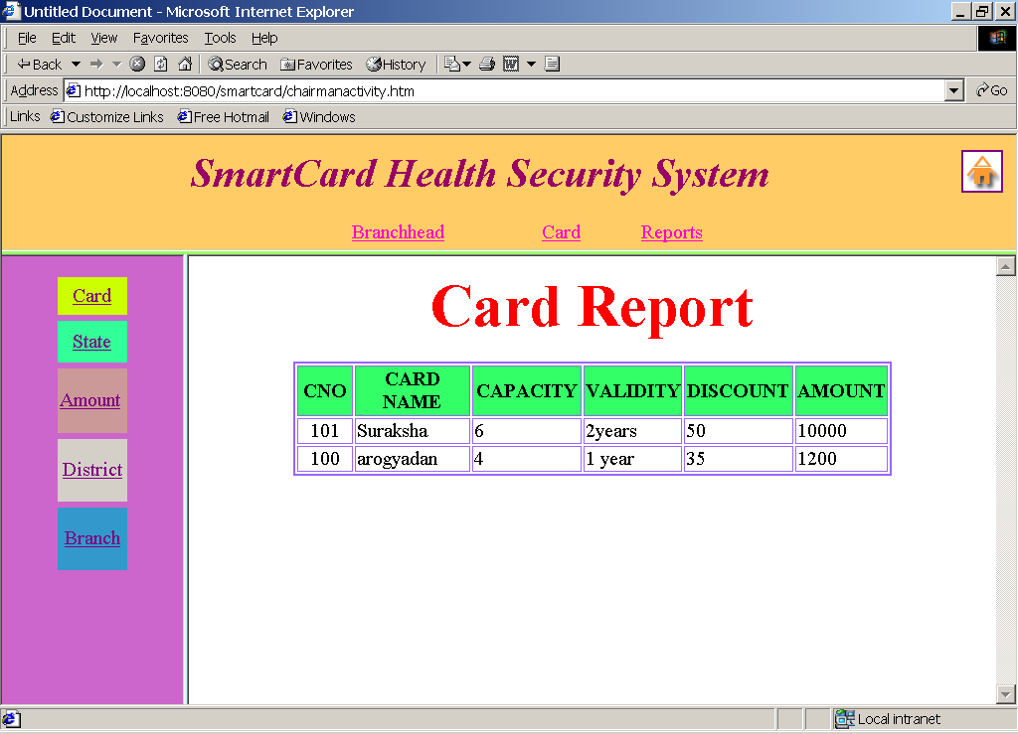

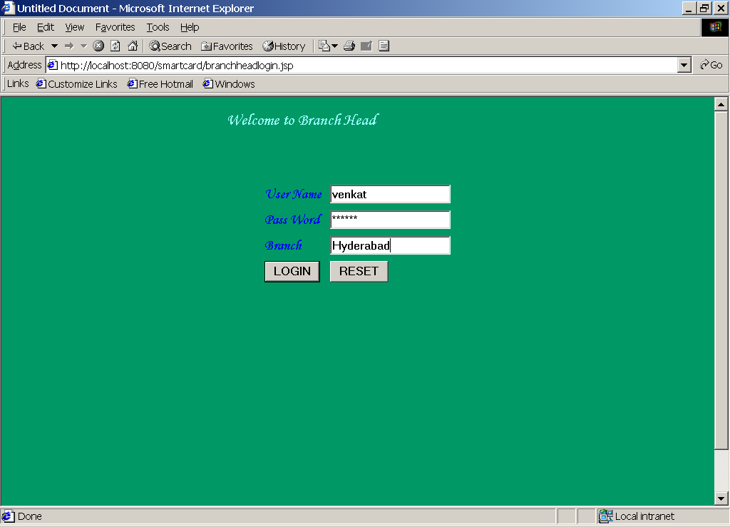

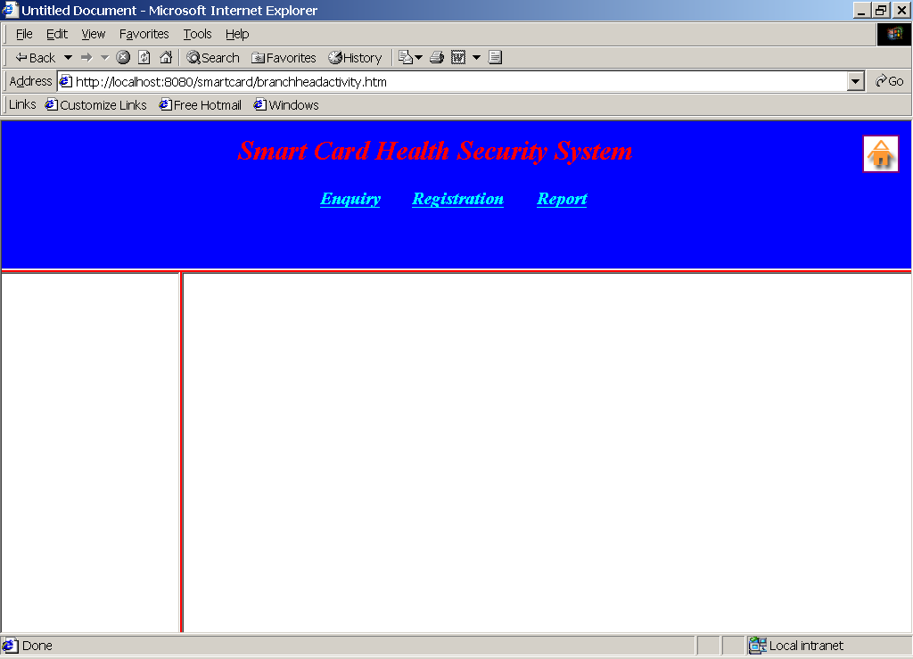

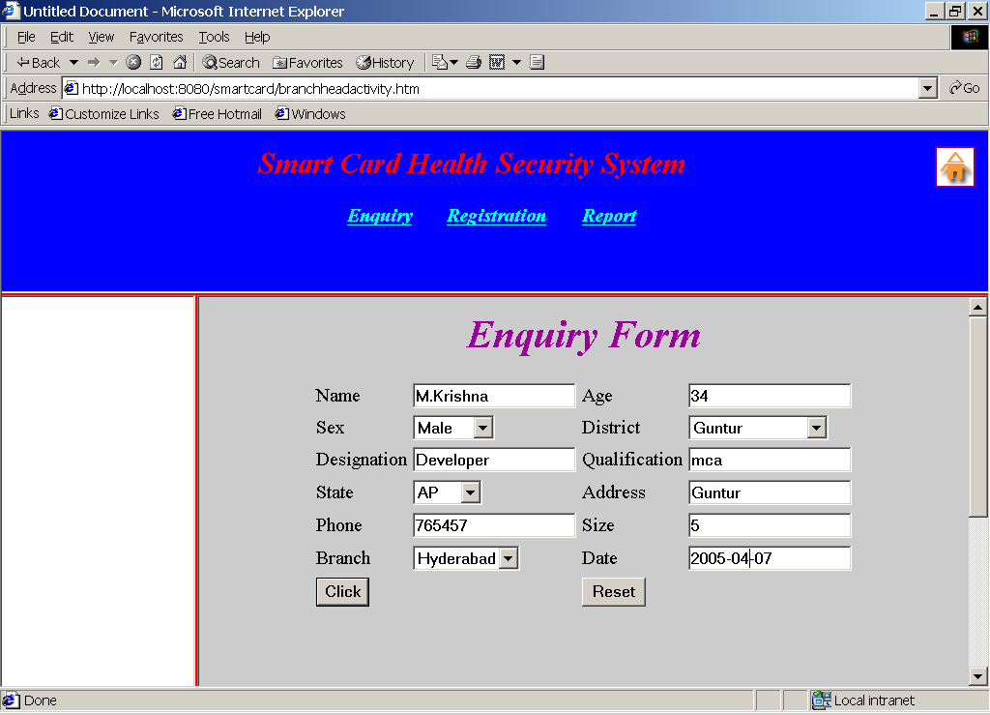

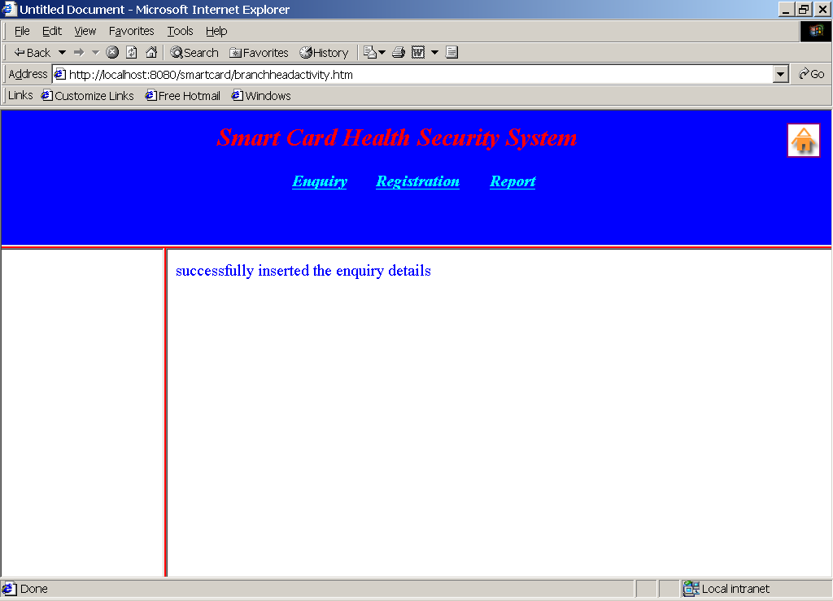

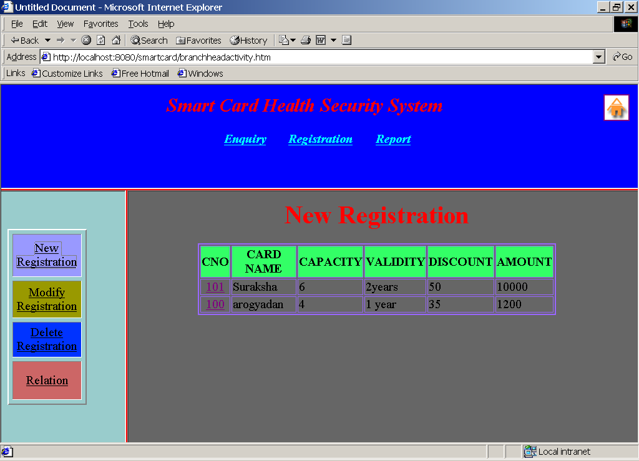

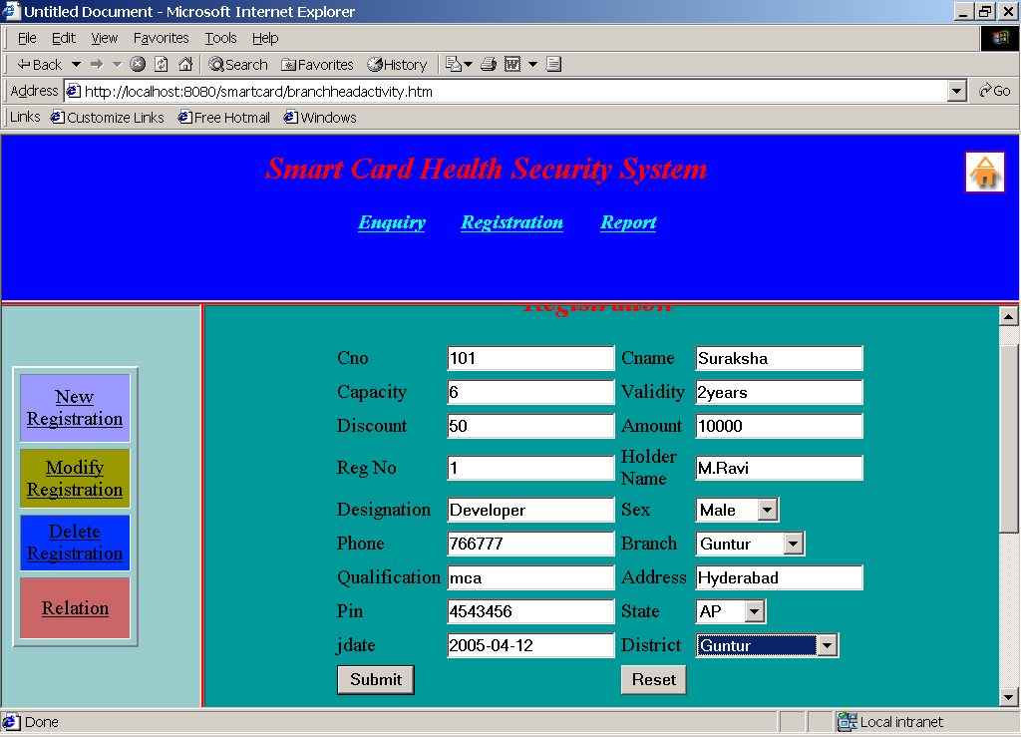

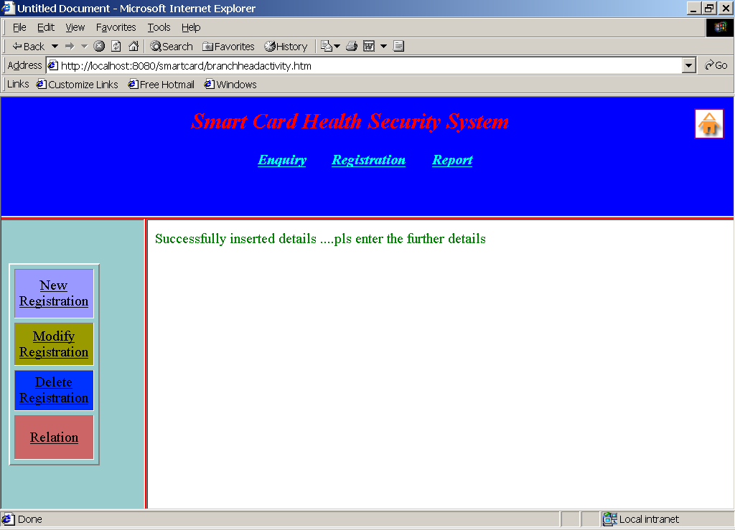

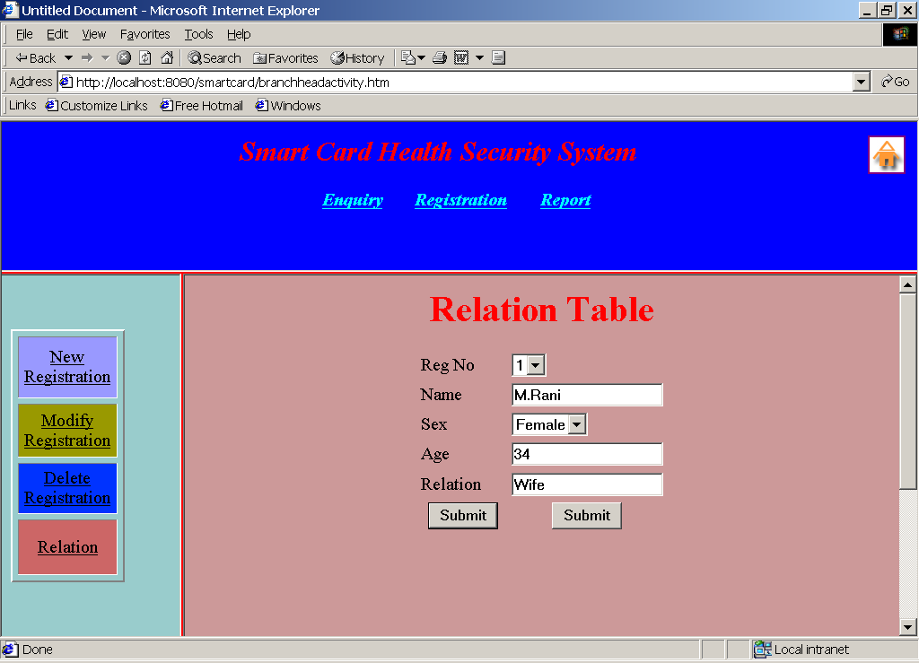

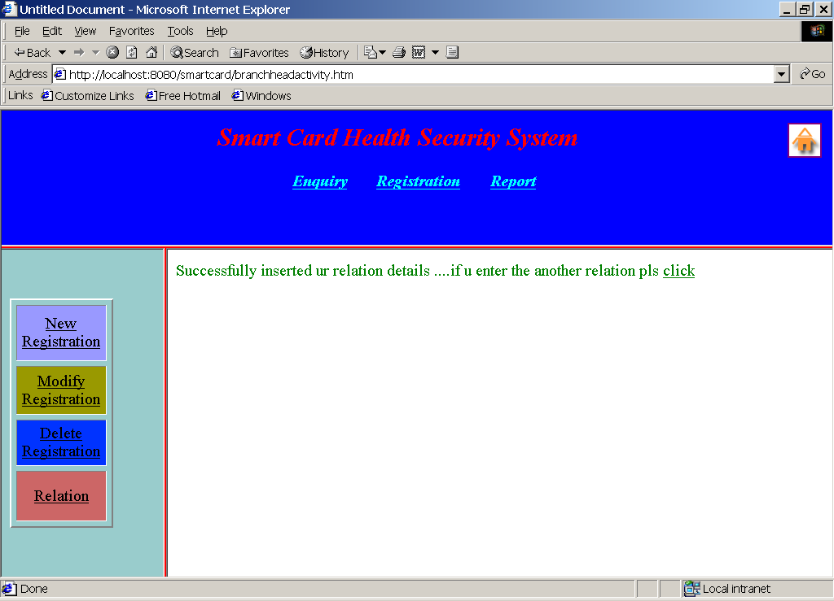

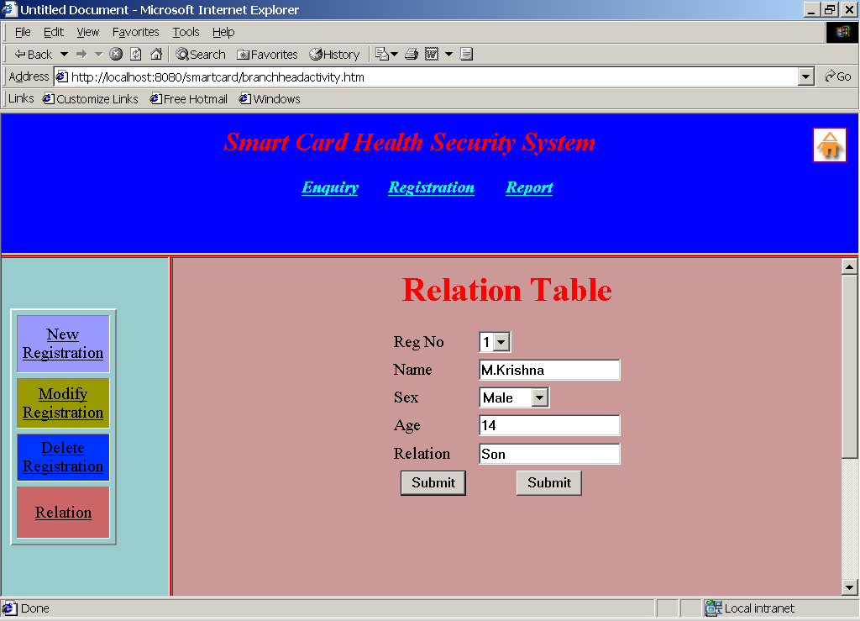

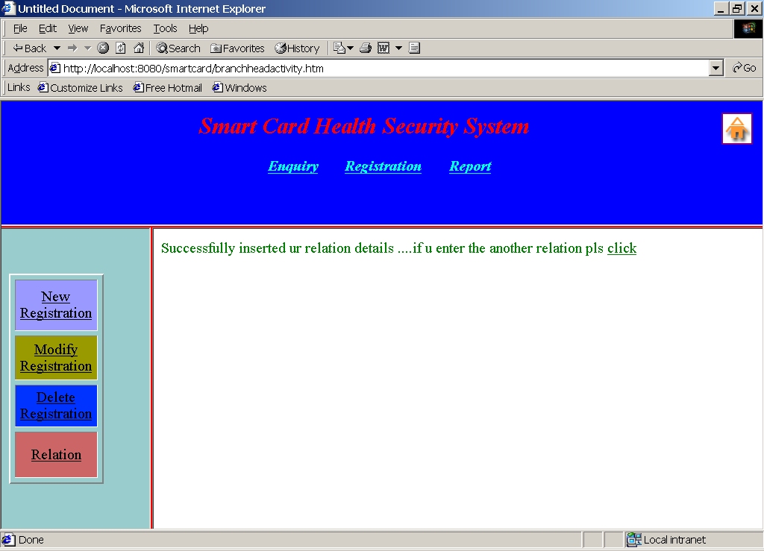

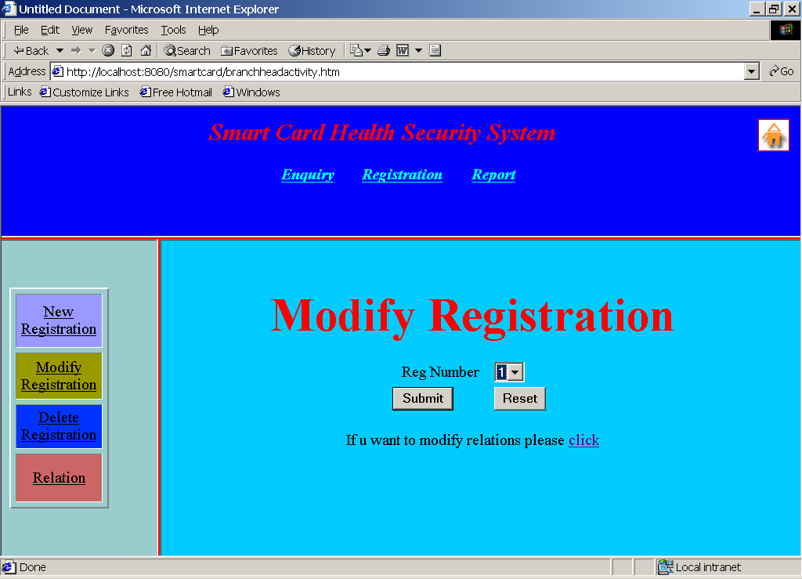

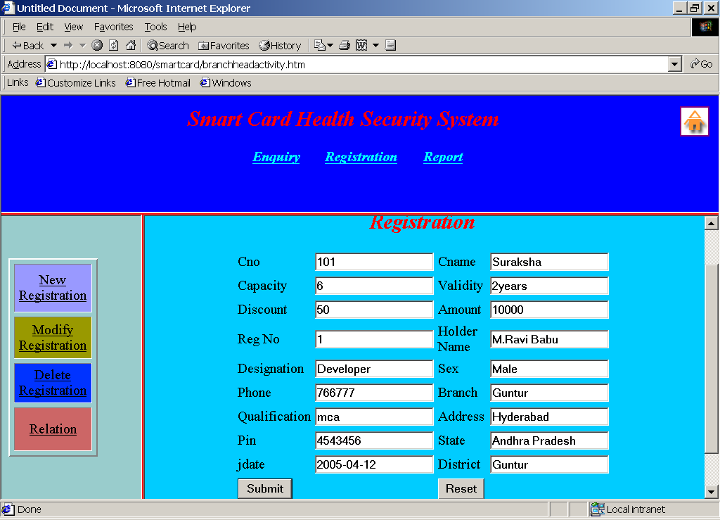

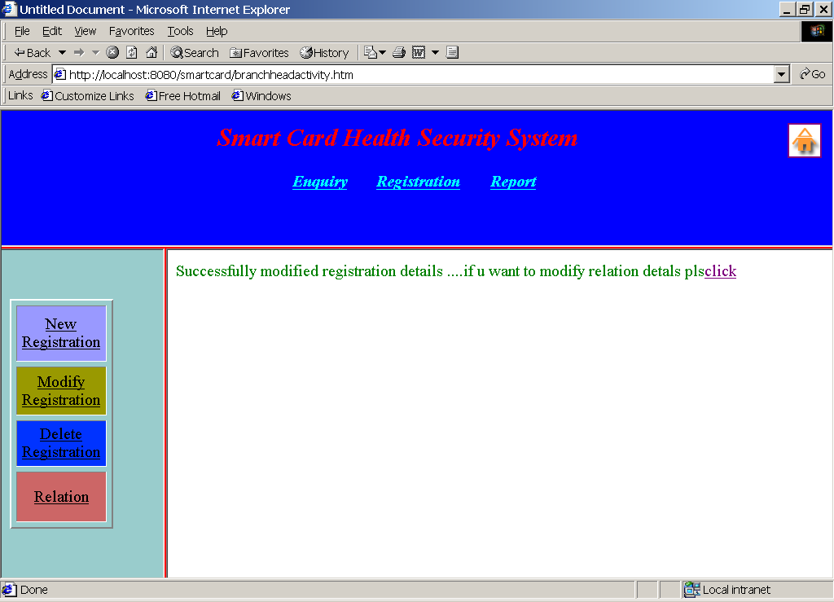

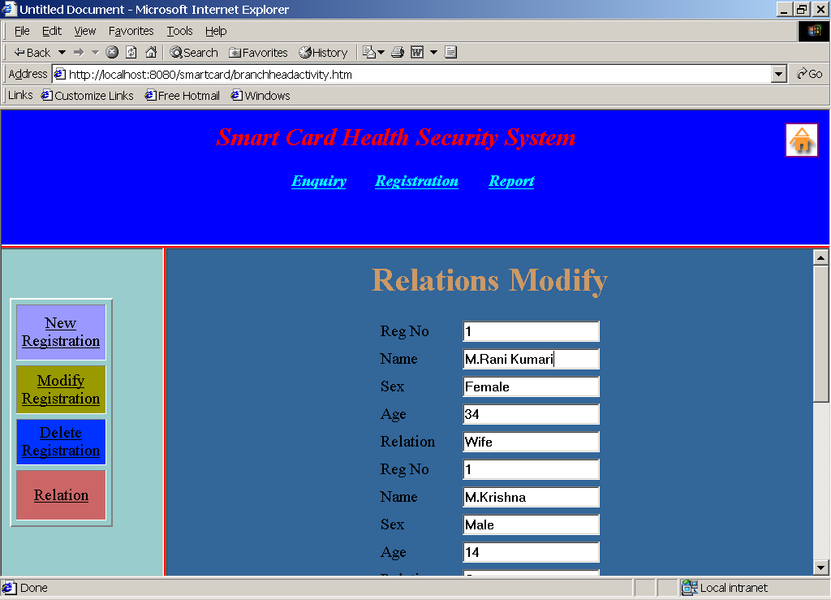

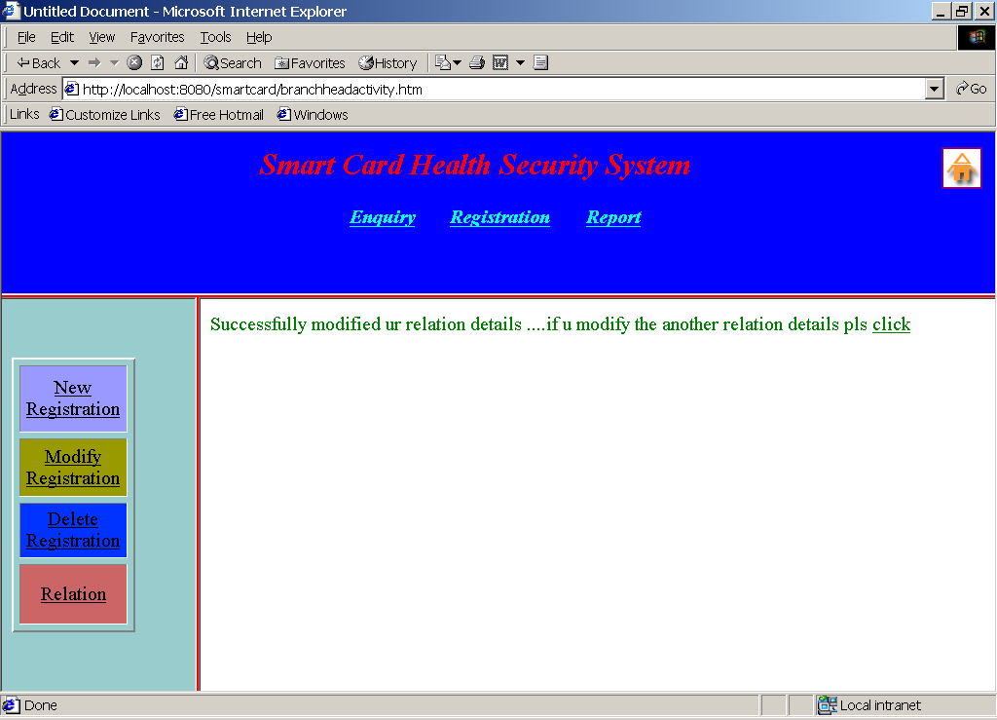

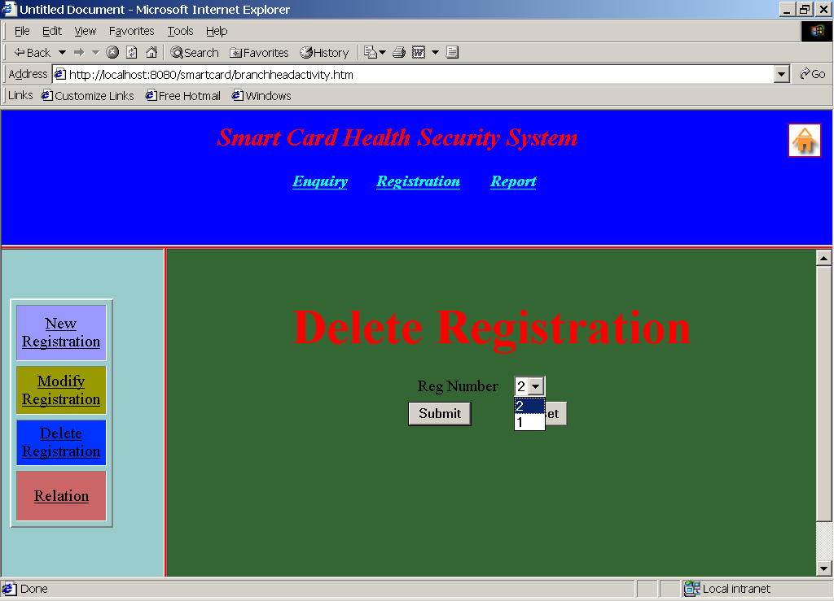

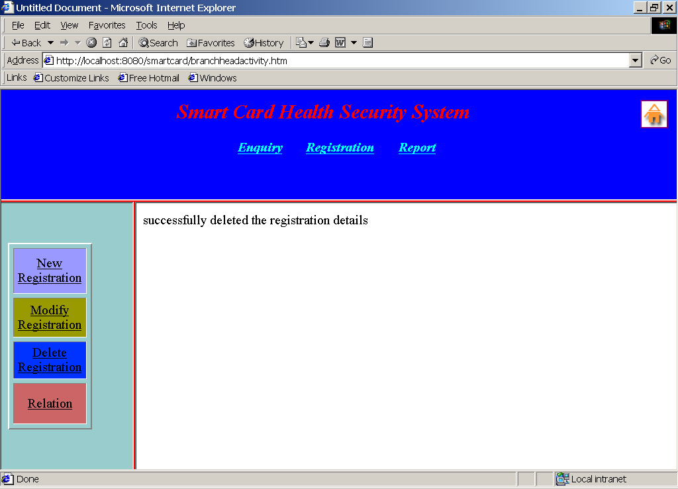

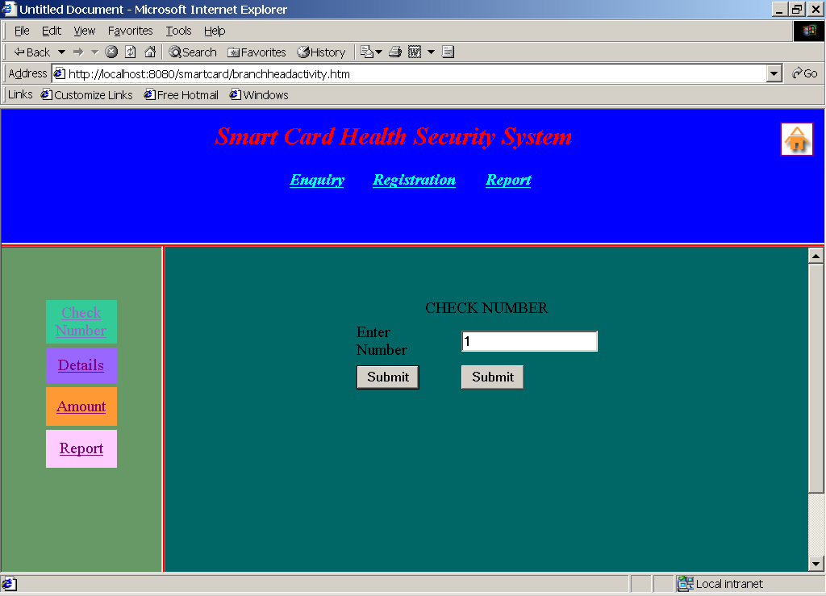

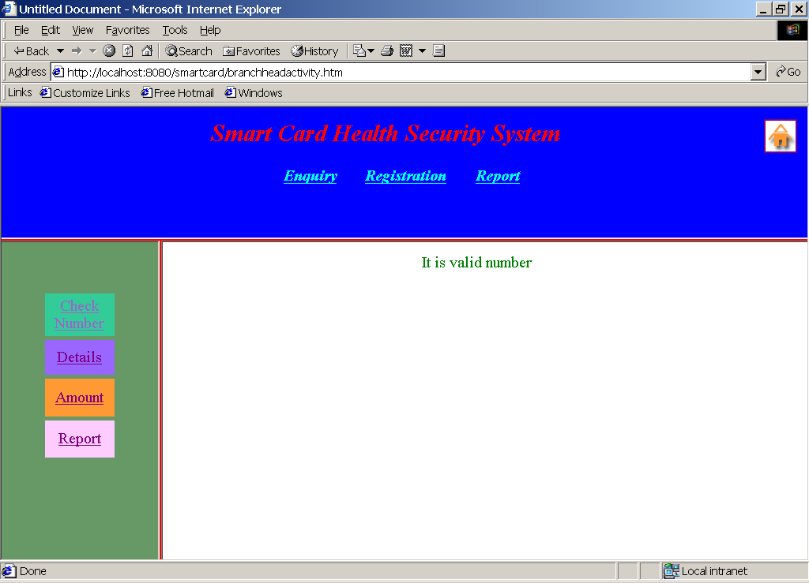

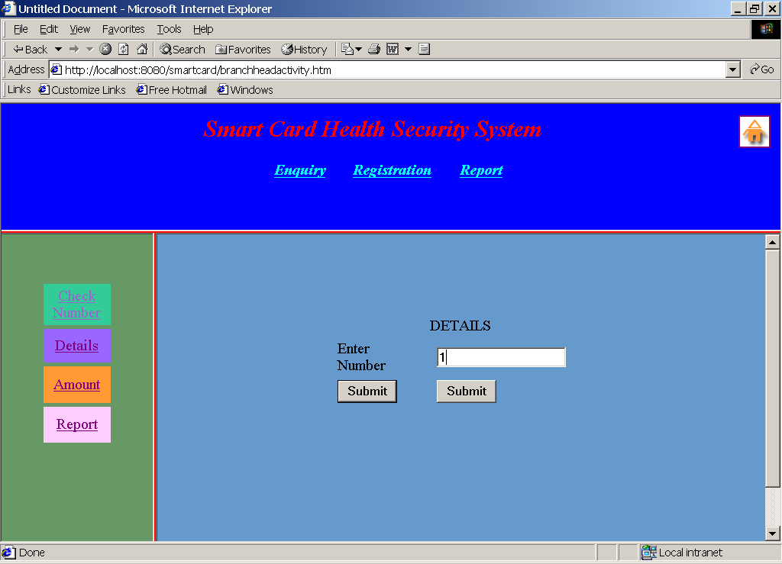

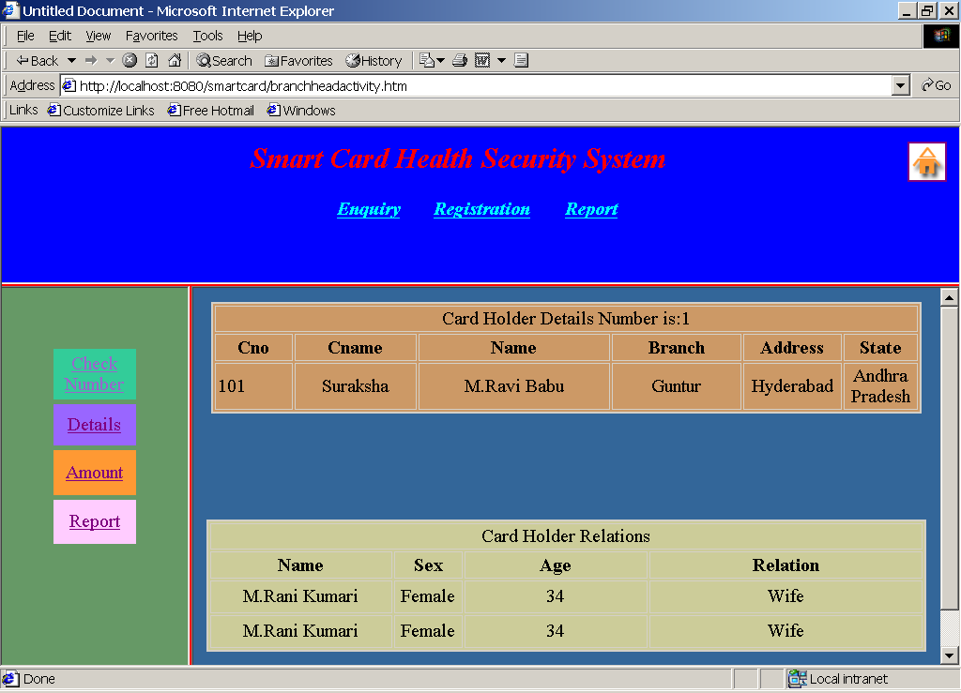

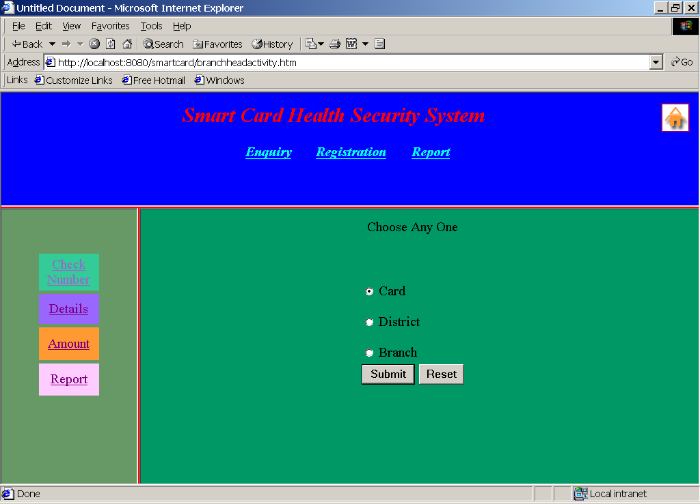

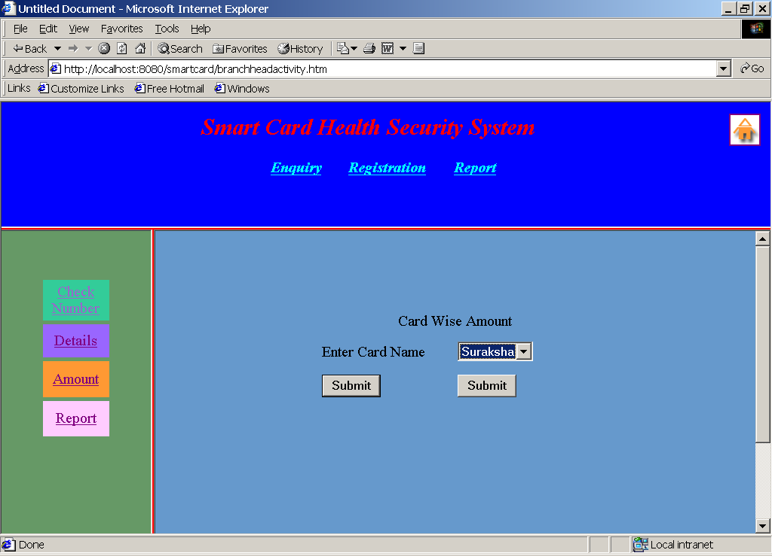

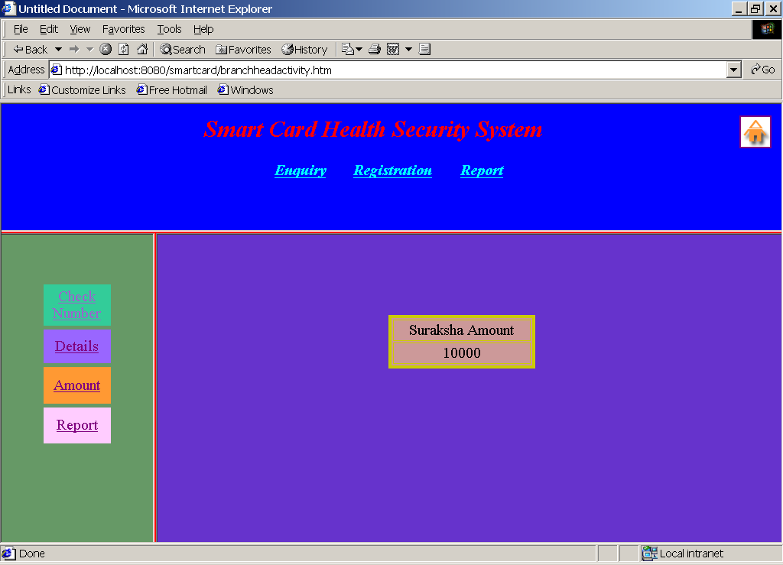

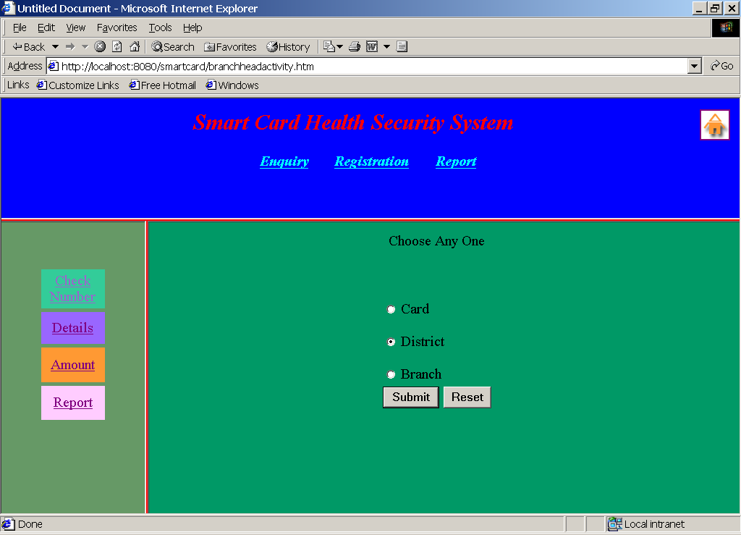

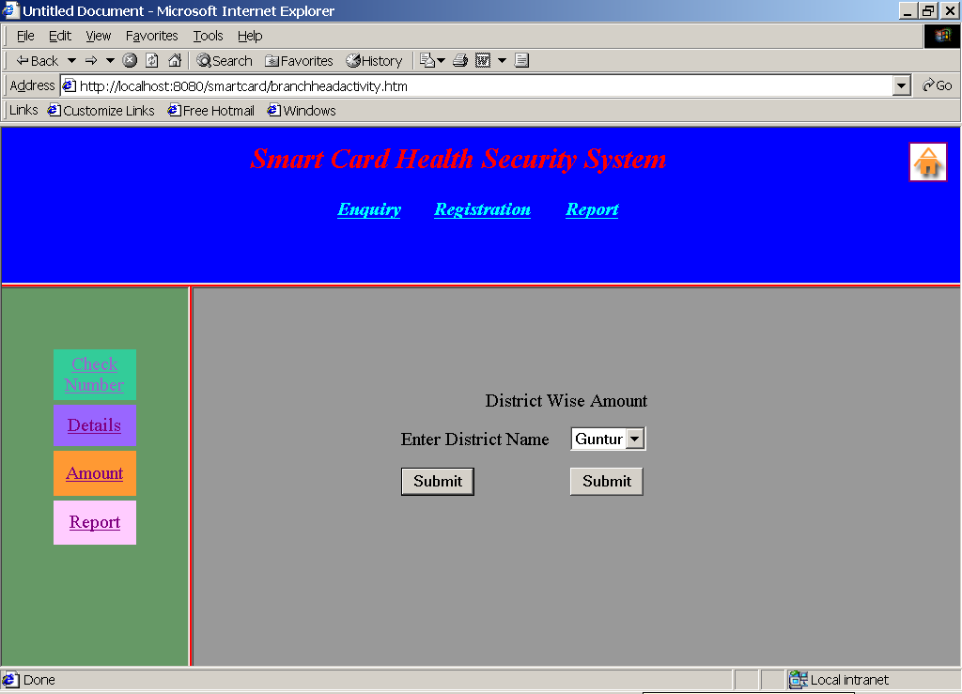

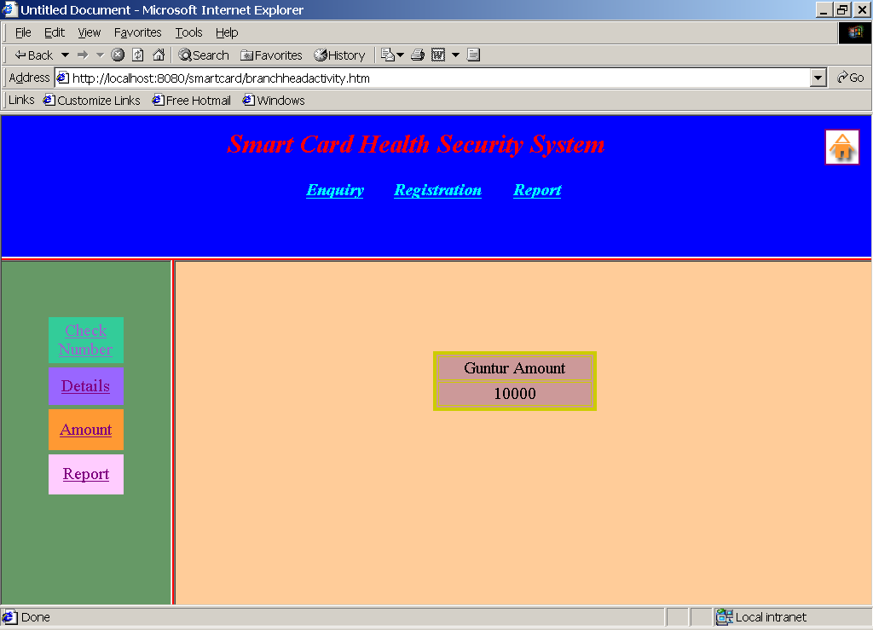

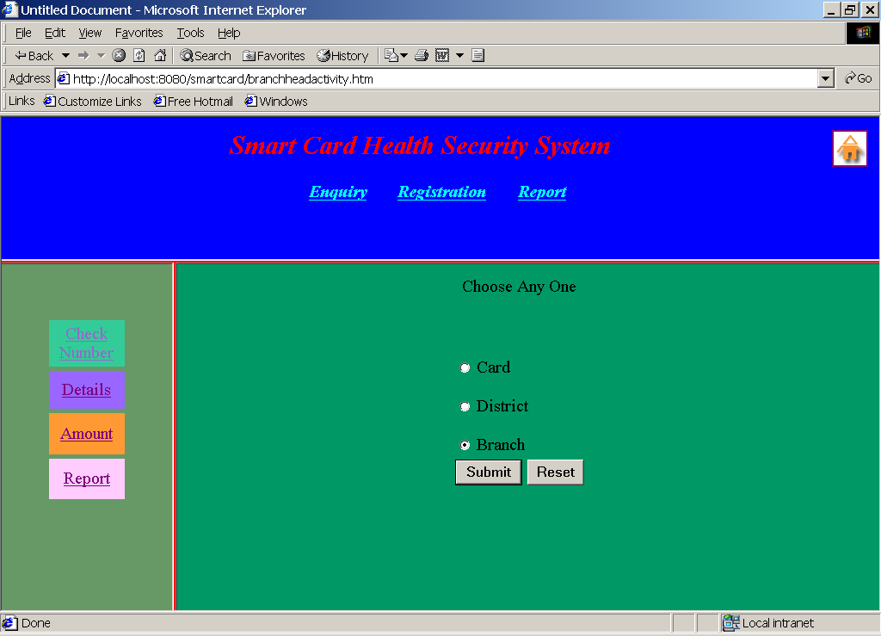

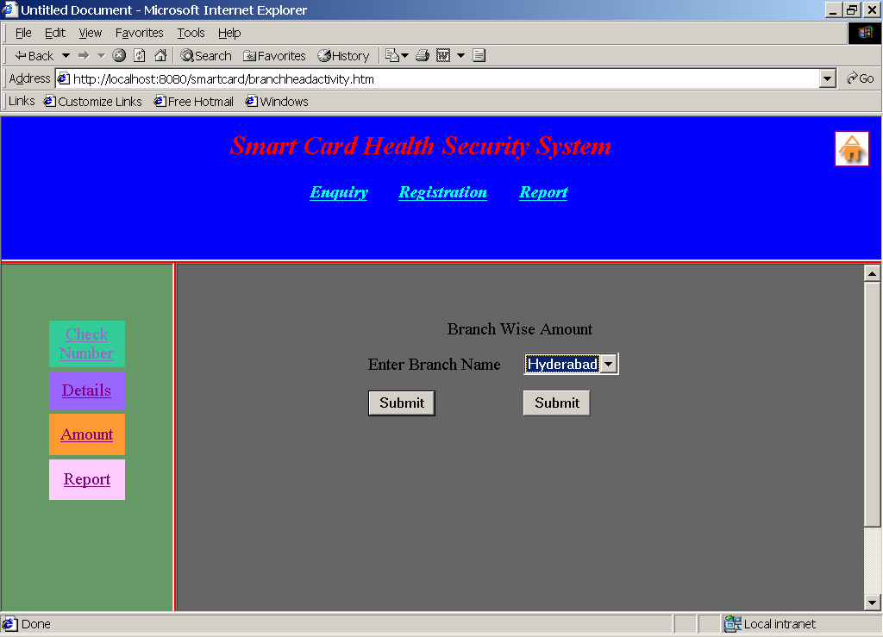

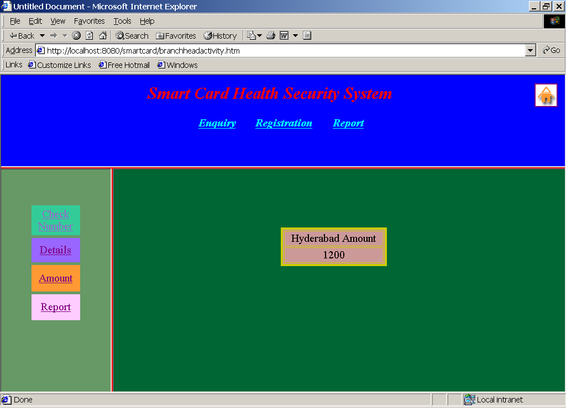

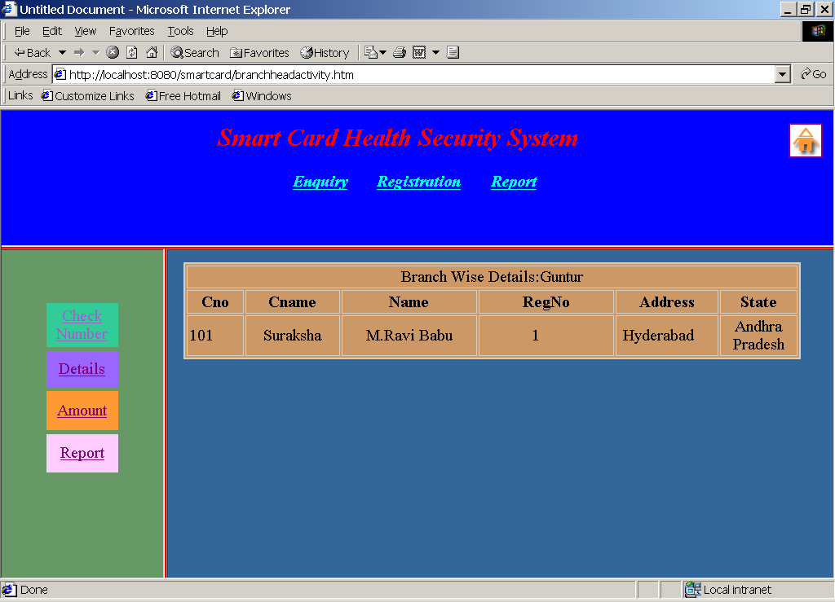

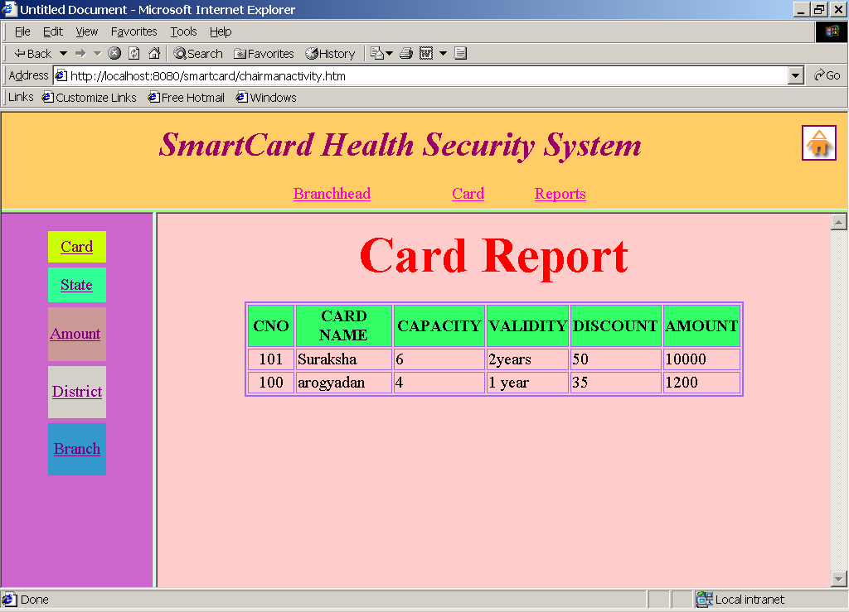

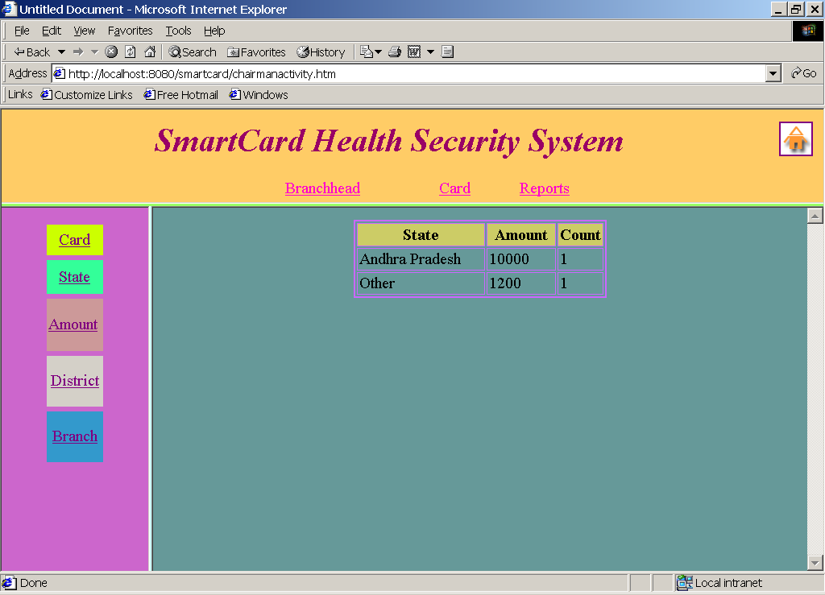

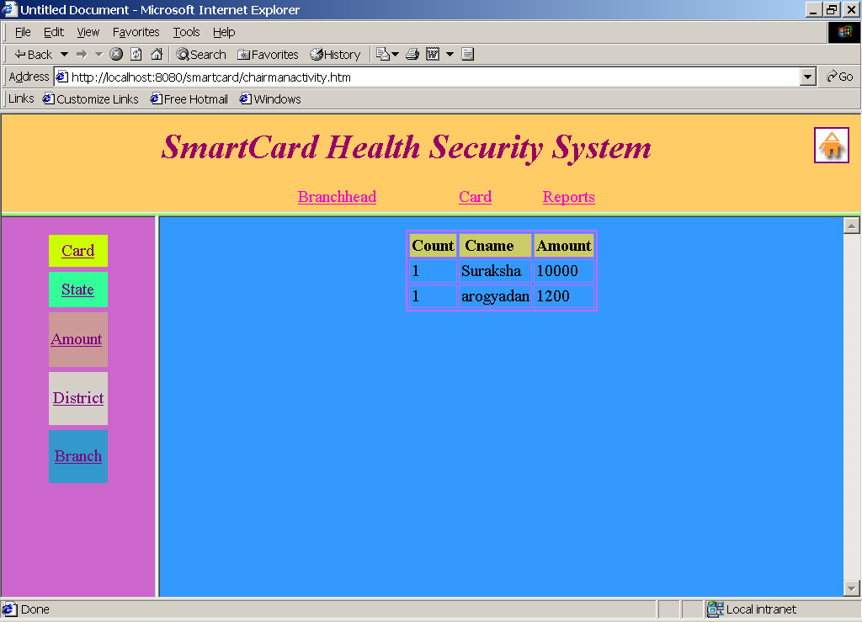

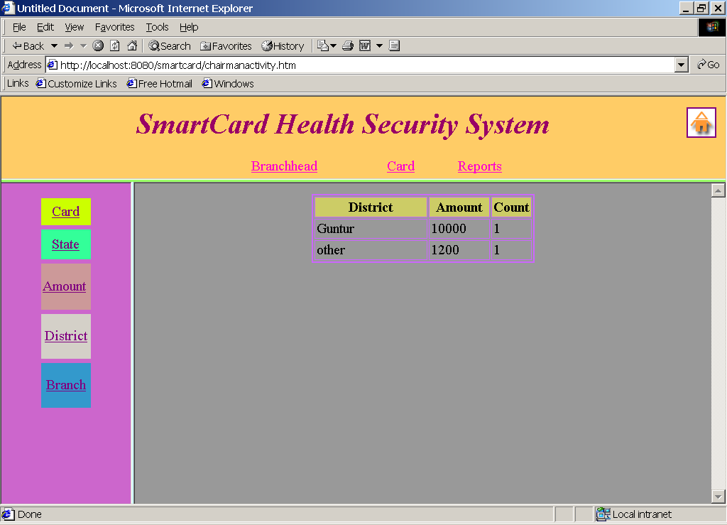

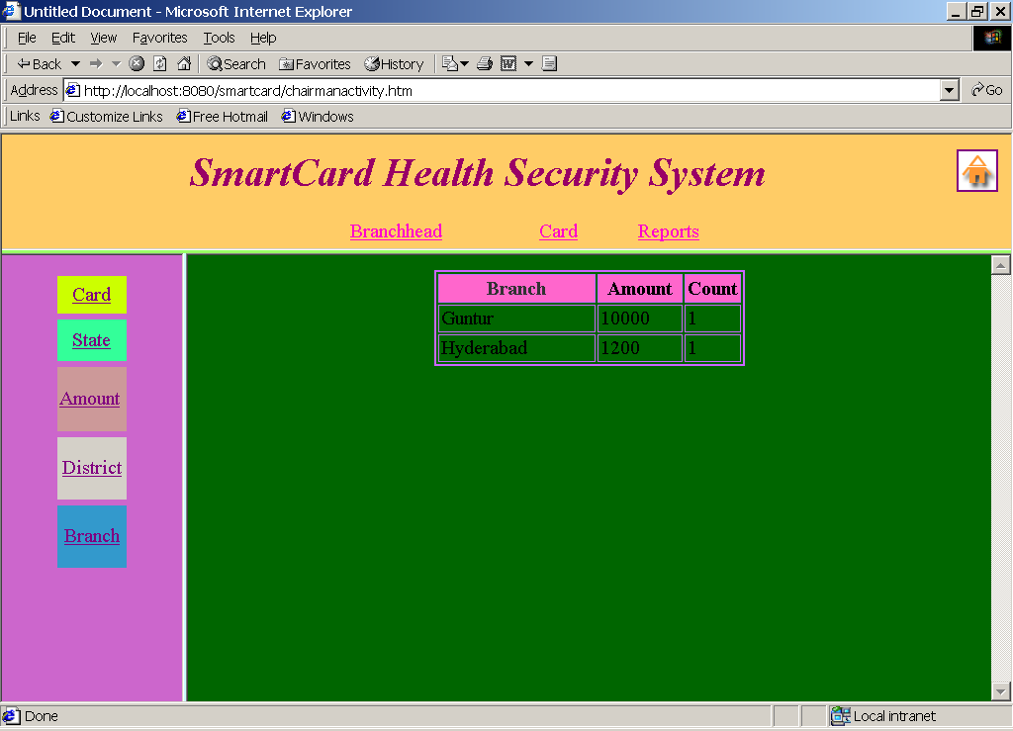

FUTURE ENHANCEMENT

- GLOBALIZATION OF SITE

- ADDITION OF SOME MORE CATEGORIES

- UPDATION MODULE

GLOBALIZATION OF SITE:
For increasing the Business World wide we may globalize the site.

ADDITION OF SOME MORE CATEGORIES:
Addition of some more new categories may takes place.

UPDATION MODULE:
For existing site Updating module may be added.

CONCLUSION

The main objective of the project is to automate the "Oraganization management". By using ORACLE as back-end and Java as front-end under WINDOWs environment.

The efficiency of any system designed to suit an organization depends cooperation during the implementation stage and also flexibility of the system to adopt itself to the organization.

This project "Smart Card" is very useful and helpful because the effiency will improve with better way of communication among Chairman-Manager, Manager- Customer. Reliable and accurate reports could be available with in a very short time, which is not possible if done manually.

BIBLIOGRAPHY

- H.M.DIETEL.P.J.DIETEL, Java How to Program, PhL, Second Edition
- Gray Cornett, Horstmann, CorelJava, Sunsoft Press, 1996.
- Patrick Naughton & Herbert Schildt, Java : The Complete Reference, Tata McGraw-Hill, Macrch 1997.
- Grady Booch, Object Oriented Analysis and Design with Applications, the Benjimin/Cummings, 1994.

